**Table 1** – Characteristics of the study population

|  |  |  |  |
| --- | --- | --- | --- |
| Main groups of cancer diagnoses | N | Age*  mean (SD) | % Females |
| Upper GI | 172 | 68.9 (12.1) | 44 |
| Lower GI | 2419 | 72.0 (10.8) | 57 |
| Pancreas | 57 | 65.0 (13.9) | 72 |
| Lung | 255 | 66.6 (11.3) | 52 |
| Melanoma | 1838 | 59.9 (14.0) | 60 |
| Breast | 4769 | 65.8 (10.2) | 100 |
| Female genitals | 2173 | 62.8 (13.0) | 100 |
| Male genitals | 923 | 45.5 (10.8) | 0 |
| Prostate | 2688 | 74.3 (7.0) | 0 |
| Kidney and urinary tract | 1296 | 69.5 (11.5) | 33 |
| Hematological | 1322 | 58.9 (15.2) | 48 |
| Other incl. CNS | 3514 | 62.3 (15.3) | 57 |
| Total | 21426 |  |  |

* Age at follow-up ten years after diagnosis.

**Table 2** – 1 year periodic prevalence of use of analgesics, benzodiazepines and benzodiazepine-related hypnotics, prevalence of persistent and high-dose opioid use and high-dose use of benzodiazepines and benzodiazepine-related hypnotics 10 years after cancer diagnosis in the age age and gender adjusted study population compared to the general population.

|  |  |  |  |  |  |
| --- | --- | --- | --- | --- | --- |
|  | Study population | | | General population | |
|  | Unadjusted | Adjusted |  |  |  |
| N/1000 | N/1000 | N | N/1000 | N |
| One year periodic prevalence of opioid use* | 176.0 | 143.5 | 3772 | 129.6 | 392927 |
| One year periodic prevalence of benzodiazepine use* | 132.9 | 88.3 | 2847 | 77.9 | 236071 |
| One year periodic prevalence of benzo-related hypnotic use* | 193.3 | 118.1 | 4141 | 97.4 | 295295 |
| One year periodic prevalence of paracetamol use*/** | 128.9 | 88.3 | 2761 | 80.7 | 244728 |
| One year periodic prevalence of NSAID use*/** | 244.1 | 229.1 | 5230 | 221.7 | 672057 |
| One year periodic prevalence of gabapentinoid use* | 18.1 | 13.4 | 387 | 10.0 | 30349 |
| Prevalence of persistent opioid use | 7.4 | 6.5 | 158 | 4.8 | 14646 |
| Prevalence of high-dose opioid use | 2.5 | 2.7 | 54 | 1.3 | 3940 |
| Prevalence of high-dose benzodiazepine use | 42.4 | 27.4 | 909 | 23.9 | 72500 |
| Prevalence of high-dose benzo-related hypnotic use | 104.5 | 56.4 | 2239 | 44.8 | 135740 |

* The one year periodic prevalence is the proportion of the study population receiving at least one prescription of the drug during the defined 365-day period.

** Only prescribed drugs. Also available in small quantities over the counter, which are not captured by Norwegian prescription database

**Table 3** – Opioid formulations during tenth year after cancer diagnosis in patients with persistent and high-dose opioid use.

|  |  |  |  |  |  |  |  |
| --- | --- | --- | --- | --- | --- | --- | --- |
|  | |  |  |  | Mean dose | |  |
|  | | N | % |  | DDD | (SD) | % short acting* |
| Persistent opioid users | | 158 |  |  |  |  |  |
|  | Long acting only | 12 | 7.6 |  | 1543 | (1210) |  |
|  | Short acting only | 74 | 46.8 |  | 1419 | (1101) |  |
|  | Long and short acting | 72 | 45.6 |  | 1782 | (1027) | 18.4 |
|  |  |  |  |  |  |  |  |
| High-dose-opioid users | | 54 |  |  |  |  |  |
|  | Long acting only | 5 | 9.3 |  | 2594 | (1201) |  |
|  | Short acting only | 16 | 29.6 |  | 2412 | (1769) |  |
|  | Long and short acting | 33 | 61.1 |  | 2422 | (1113) | 20.4 |

* % of DDD with short acting formulations in patients receiving both short and long acting formulations.

All patients aged 18+ diagnosed with cancer in Norway between 01.01.1998 and 30.04.2002 83993

>Dead within 10 years after diagnosis 57063

Cancer patients alive 10 years after diagnosis 26930

> Dead between 10 and 15 years after diagnosis 5504

Cancer patients alive 15 years after diagnosis 21426

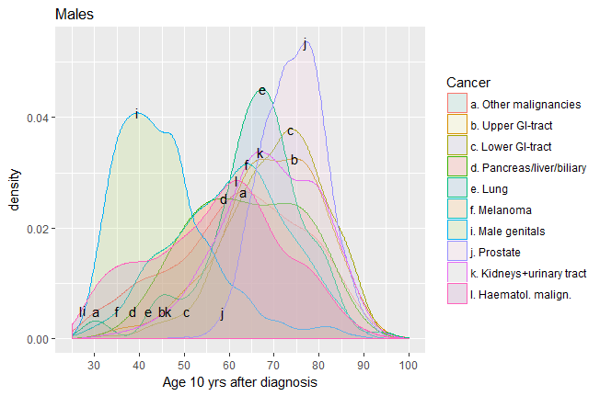

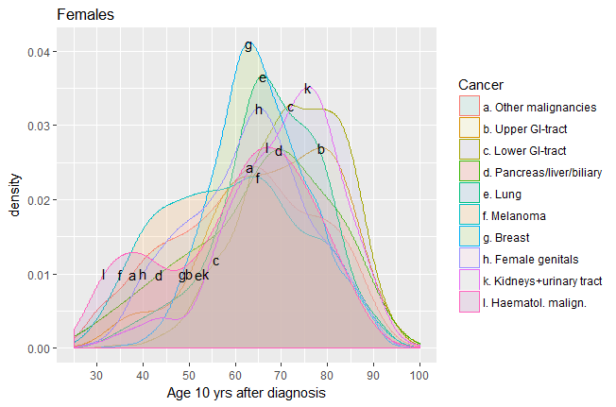



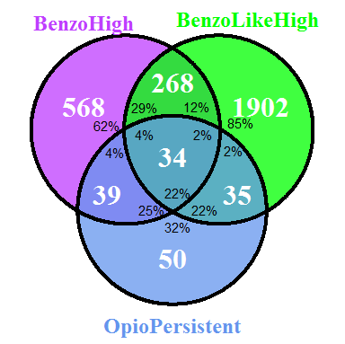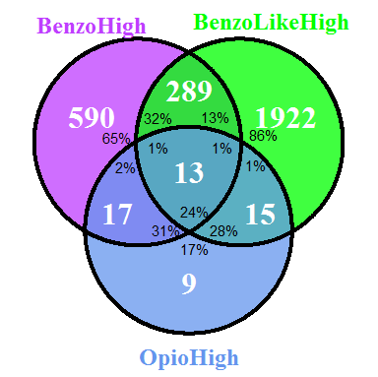

Persistent opioid use

>100 DDD Benzodiazepines/year

>100 DDD Benzo-related hypnotics/year

High-dose opioid use

>100 DDD Benzodiazepines/year

>100 DDD Benzo-related hypnotics/year