Figure 1. Correlations between included variables

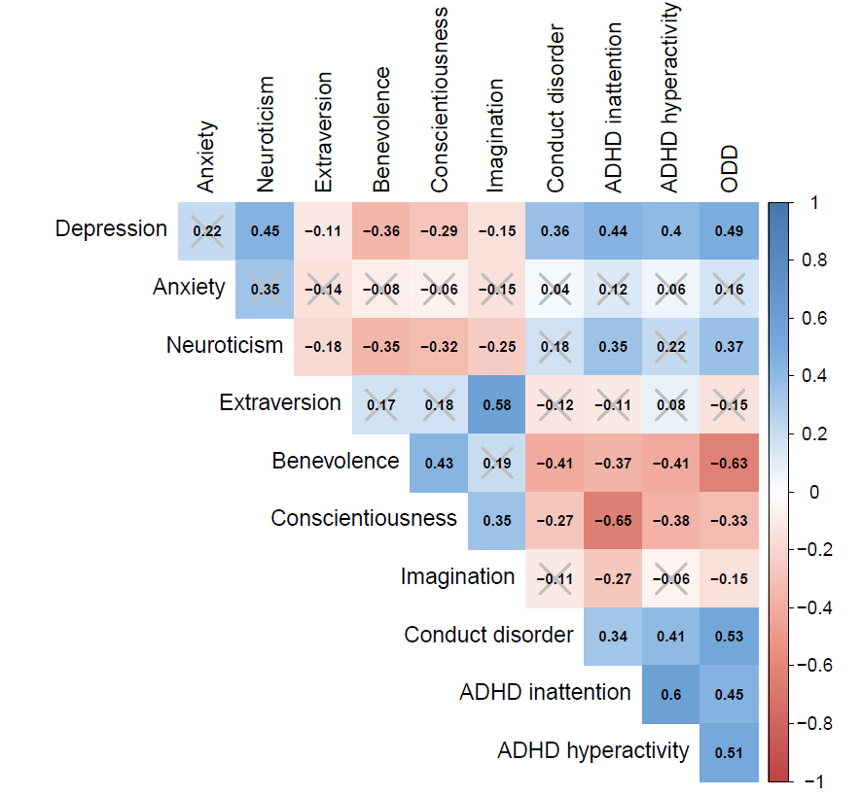

Note: Grey cross indicates correlations not significant (p >.05).

