Figure 3. Predicted latent factor scores for different levels of gestational age
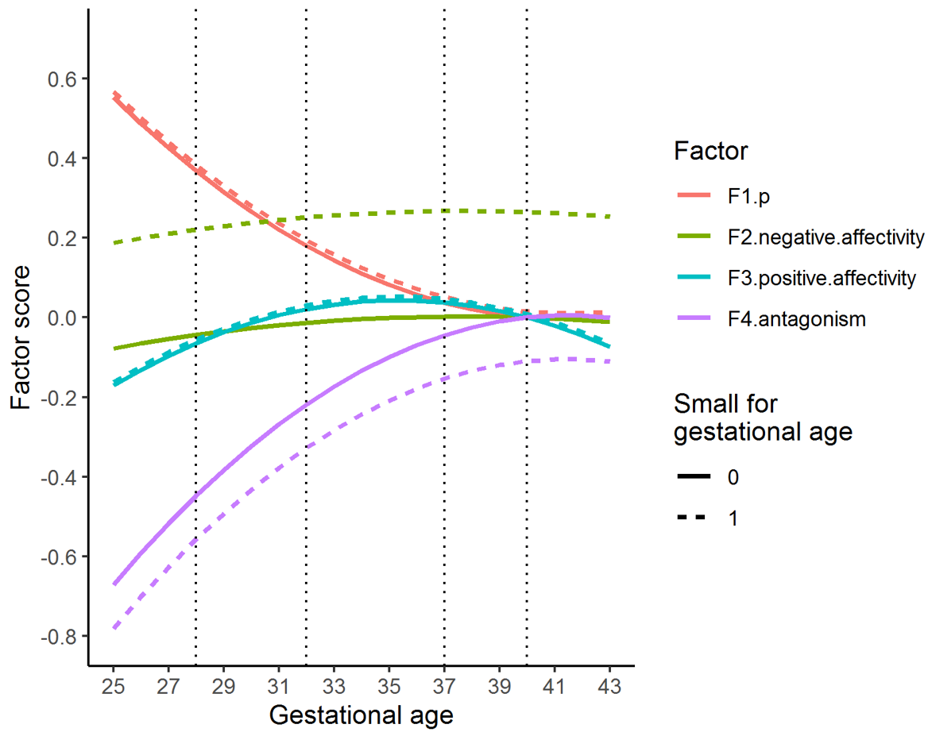
The figure shows the association between gestational age and p, as well as between gestational age and the residual latent factors (F2-F4), expressed as predicted factor scores for different levels of gestational age. Factors have mean = 0 and standard deviation of 1. The vertical lines index gestational age 40 (term), 37 (early term), 32 (very preterm) and 28 weeks (extremely preterm). Dotted lines are predicted factor scores for children born small for gestational age.

