Is Affluence a Risk for Adolescents in Norway?
Terese J. Lundª
Eric Dearing^{b}
Henrik Daae Zachrisson^{c}

ª Corresponding Author; Department of Psychology, Wingate University, 220 N. Camden Road, Wingate, NC 28174, t.lund@wingate.edu
^{b} Department of Counseling, Developmental, and Educational Psychology, Lynch School of Education, Boston College, 140 Commonwealth Avenue, Chestnut Hill, MA 02467, eric.dearing@bc.edu
^{c} The Norwegian Center for Child Behavioral Development and The Norwegian Institute of Public Health, The Norwegian Center for Child Behavioral Development​, PB 7053 Majorstuen, 0306 Oslo, Norway, h.d.zachrisson@atferdssenteret.no
Abstract
Studies suggest that affluence poses a risk for adolescents, but this has rarely been studied outside the United States. We examined the unique and additive roles of family and school affluence for adolescent outcomes among 10th grade students (n = 7203) in Oslo, Norway. Multilevel models were estimated separately by gender. For both boys and girls, school affluence was a risk for alcohol abuse and family affluence was a risk for conduct problems, although for conduct the risk was only at the very highest end of income distribution and adolescents in very poor families were also at risk. There was also a complex pattern of risk for early sexual debut; family affluence posed risk, but school affluence appeared protective.

Introduction
While living in affluence has for many years been treated as an asset for youth, there is increasing evidence that contexts of exceptional wealth may pose some risk, especially for adolescent social-emotional well-being (e.g., Luthar & Latendresse, 2005a). Several studies in the United States using community and nationally-representative samples have demonstrated that adolescents growing up in the context of affluence often experience heightened levels of social-emotional problems (e.g., anxiety) and risky behaviors (e.g., alcohol use) compared to national norms (Luthar & Becker, 2002) and compared with adolescents who are not affluent (Coley, Sims, Dearing, & Spielvogel, in press; Luthar & D’Avanzo, 1999; Lund & Dearing, 2012). This research also suggests that the risk associated with affluence appears unique to adolescence and may impact boys and girls differently (Luthar & Becker, 2002; Lund & Dearing, 2012). Most recently, researchers have become increasingly concerned with unpacking the ecological level(s) where risk resides, whether that be due to growing up in affluent families, schools, neighborhoods, and/or a larger societal context of disparities in wealth (e.g., Coley, Sims, Dearing, & Spielvogel, in press; Lund & Dearing, 2012).
Why Might Affluence Be a Developmental Risk? Conceptual and Theoretical Background
A number of mechanisms have been proposed to explain the heightened levels of social-emotional maladaptation among affluent youth, with ineffective parenting being one proximal process of concern (Luthar & Goldstein, 2008; Luthar & Barkin, 2012). High parental workloads, for example, may impair affluent parents’ monitoring of their adolescents’ behavior (Luthar, 2003; Luthar & Latendresse, 2005a; Luthar, Barkin, & Crossman, 2013). Although direct tests of mediation hypotheses for the developmental effects of affluence are rare, affluent parents with little knowledge of their child’s whereabouts, are more likely to have children with problem behaviors (e.g., higher levels of substance use) than those with greater knowledge (Luthar & Barkin, 2012). Low levels of parental monitoring (Luthar & Becker, 2002; Luthar, Shoum, & Brown, 2006) and few perceived consequences for misbehavior (i.e., limited parental containment) are also associated with higher levels of problems in contexts of affluence (Luthar & Goldstein, 2008; Luthar & Barkin, 2012). Moreover, high parental expectations for achievement may be a stressor for affluent youth. Extraordinary pressures to excel, such as experiences of parental criticism, have been associated with higher levels of non-suicidal self-injury (NSSI), delinquency, and internalizing problems for affluent adolescents (Luthar et al., 2006; Yates, Luthar, & Tracy, 2008). Relatedly, affluent youth who believe that their parents value achievement over character are also likely to experience dysfunction (Luthar & Becker, 2002; Luthar & Latendresse, 2005b).
Beyond the family environment, affluent schools and communities may add to achievement pressures (Luthar, 2003; Levine, 2006; Luthar et al., 2013). Competition within schools might rob youth of critical social support and school connectedness, both of which are known to positively influence adolescent development across a wide variety of domains (e.g., Goodenow, 1993; Demaray & Malecki, 2002; Anderman, & Freeman, 2004). Competition among neighbors for “scarce resources” such as scholarships, awards, and admittance to elite universities and colleges is also likely to erode social cohesion (Jencks & Mayer, 1990; Leventhal & Brooks-Gunn, 2000). Moreover, social comparisons made at school and among neighbors to more affluent youth can generate feelings of relative deprivation (Festinger, 1954; Jencks & Mayer, 1990) and ultimately harm social-emotional well-being (Luthar & Sexton, 2004).

Gender and Affluence
Research suggests that adolescent boys and girls may demonstrate differential susceptibility across domains of well-being and behavior (Luthar & Becker, 2002; Luthar et al., 2006; Lund & Dearing, 2012). Luthar and colleagues have repeatedly demonstrated that affluent girls report higher levels of anxiety and depression than national norms (Luthar & D’Avanzo, 1999; Luthar & Becker, 2002; Luthar & Barkin, 2012). Luthar and D’Avanzo (1999), for example, found that greater than one in five girls (22%) experienced clinically significant levels of depressive symptoms. These rates were almost three times higher than national norms (Luthar & D’Avanzo, 1999). In addition, as many as one in five affluent girls in U.S. samples report clinically significant anxiety (Luthar & Becker, 2002).
While affluent girls often report greater levels of internalizing problems than their male counterparts, boys in the context of affluence may experience difficulties in these domains, too, although the evidence is less robust. In one study, affluent boys reported clinically significant anxiety problems at greater rates than national norms (26% vs. 17%) and at greater rates than their female counterparts (26% vs. 22%) (Luthar & D’Avanzo, 1999). More recently, however, Luthar and Barkin (2012) found that adolescent girls had higher anxiety-depression mean scores and more often reported clinically significant levels of anxiety-depression than adolescent boys. In addition, although Lund and Dearing (2012) found significant associations between neighborhood affluence and anxiety and depression for girls, they found no such association for boys. On the other hand, affluent boys have demonstrated higher levels of delinquency compared to affluent girls (Lund & Dearing, 2012; Luthar et al., 2006; Luthar & Goldstein, 2008). Furthermore, affluent boys appear more likely to display externalizing problems at clinically significant levels than affluent girls (Luthar & Barkin, 2012).
Yet, affluence may pose fairly similar risks for boys and girls in some domains, including risky behaviors such as alcohol and drug abuse. Previous research has demonstrated heightened rates of substance abuse among affluent youth – including alcohol, marijuana, cigarettes, and other drugs (Lyman & Luthar, 2014) – with findings appearing most robust for alcohol (Luthar & D’Avanzo, 1999). And, Luthar and colleagues have repeatedly demonstrated that rates of drinking in the past year and being drunk in the past year are higher than national norms and higher than less advantaged youth for both affluent boys and girls (Luthar & D’Avanzo, 1999; Luthar & Goldstein, 2008; Lyman & Luthar, 2014). Despite long standing theoretical and conceptual work on the clustering of risky behaviors, little research has been conducted on affluent youth risk-taking in domains other than drug and alcohol abuse or externalizing behavior problems; notably absent, for example, has been work on risky sexual behaviors among affluent youth, although risk of early sexual activity (before the age of 15) appears comorbid with substance abuse and externalizing problems in this population for both boys and girls (Racz, McMahon, & Luthar, 2011).
Family Versus School and Community Affluence
Most empirical work has been unable to disentangle family affluence from affluence at the community and/or school level (i.e., the aggregated concentration of affluent families within communities and schools). That is, how much money a family has often been conflated with the concentration of affluence in communities and schools, because much of the original research was based on samples of adolescents from single communities within the Northeastern region of the United States. Yet, more recently, Luthar and Barkin (2012) utilized data from several samples, including a West coast and two East coast samples, to demonstrate that affluent youth who are diverse with regard to geography evidence social-emotional problems.
In addition, in a geographically diverse sample from 10 regions in the U.S., Lund and Dearing (2012) disentangled the unique contributions of family and neighborhood affluence. Controlling for family affluence, this work indicated that youth from affluent neighborhoods were at an increased risk for social-emotional problems compared to their counterparts from middle-class neighborhoods; girls from affluent neighborhoods reported high levels of anxiety-depression and boys from affluent neighborhoods reported high levels of delinquency. On the other hand, holding constant these neighborhood associations, family affluence was not associated with problems for boys or girls. More of this type of work is needed to precisely identify where within their social ecologies the risk of affluence lies for adolescents. Moreover, expanding empirical work beyond the U.S. could further our understanding of the potential role of larger sociopolitical contexts; indeed, the risk of affluence may be more likely to arise in some sociopolitical contexts than others as a function of the distribution of income, culture, and/or economic policy.
While research in the U.S. has begun to disentangle the impact of family vs. school/community affluence on adolescent functioning, no research has examined affluence as risk for adolescent development outside of the United States. International extensions in a range of sociopolitical contexts could help better identify when, where, and why affluence may pose risks to healthy development; cross-cultural variations could, in fact, help identify mechanisms of risk and potential moderators of that risk. To the extent that these forces are present, affluence may compromise healthy growth and development outside the U.S. as well. On the other hand, international variations in the distribution of income and relative advantage versus disadvantage, economic and family policy, and cultural norms are but a few of the potential moderators of risk patterns identified within the United States.
Taken together, affluence effects may depend on a variety of factors. Research with samples from the U.S. suggest that the risk associated with affluence may vary as a function adolescent gender, as well as the context of affluence (family vs. community/school) Yet, it is unclear whether and how affluence poses a risk for adolescent development outside of the United States.
Affluence within the Norwegian Sociopolitical and Cultural Context
With the goal of extending the cumulative knowledge beyond the U.S., we examined family and school affluence as predictors of adolescent social-emotional well-being (e.g., depression) and risk-taking behaviors (e.g., early sexual debut) in Norway’s capital city of Oslo. Like the U.S., Norway is a wealthy nation, but it has much lower levels of economic disparity. More specifically, Norway is a wealthy social democracy (per capita GDP of ~95,000 USD in Norway compared with per capita GDP of ~51,000 USD in the United States) with low unemployment (< 3% in 2008, UN, 2011) and the third smallest gap between its poorest and wealthiest citizens among OECD countries (the U.S., for comparison, has the fourth largest; OECD 2011).
Comparisons with the exceptional inequality in the U.S. should not, however, obscure the fact that the distribution of income is substantially skewed in Norway. For example, the top 10% of households own 53% of Norway’s wealth and the top 1% own 21% (Statistics Norway, 2012). Moreover, the city of Oslo has larger income inequalities compared to the rest of Norway. For instance, while the average income in Oslo is about 13% higher than the country average, so is the rate of low-income families (in 2005, it was 14.3% in Oslo, compared to 9.6% in total in Norway; Kirkeberget & Epland, 2007). With regard to education, Norway has an egalitarian school system, with most students attending local public schools (<2% of students attended private schools; Norwegian Directorate of Education and Training, 2013) that follow the same national curriculum in a single-track school system. Although an explicit aim of the Norwegian school system is to promote equal opportunities, repeated national reports, including one covering the cohorts in our study (Hægeland, Kirkebøen, Raaum, & Salvanes, 2005) consistently find family background to account for considerably more variability in achievement than do schools per se.
Beyond national and regional economy, it is also worth calling attention to cultural differences between the U.S. and Norway. A larger cultural context characterized by individualism and materialism may exacerbate risks posed by affluence for youth development. In the U.S., increased affluence has led to a greater focus on materialism and extrinsic goals, but a reduction in happiness and well-being (Myers, 2000). In fact, historical trends indicate younger generations (i.e., “Millennials” and “Generation X”) may value extrinsic goals (e.g., money) more and intrinsic goals (e.g., community) less than previous generations (i.e., Baby Boomers) (Twenge, Campbell, & Freeman, 2012). This may be particularly true in affluent communities. Lyman and Luthar (2014), for example, found that affluent youth reported valuing extrinsic goals over intrinsic goals at greater levels than economically disadvantaged youth. In turn, a focus on extrinsic goals was linked with higher social-emotional problem levels (Lyman & Luthar, 2014). Similar to the United States, Norway has seen a shift towards materialism in recent decades, which has been accompanied by diminished well-being (Hellevik, 2003). However, Norway is more collectivistic than the U.S., with sociopolitical leanings favoring the value of the welfare state and the role of government in the distribution of wealth (Esping-Andersen, 1990). Nonetheless, given the lack of international data on affluent youth, it is not clear how (or if) sociopolitical and cultural differences might affect the relation between affluence and risk.
Present Study
In the present study, we examined family affluence and concentrated affluence within schools as predictors of adolescent social-emotional well-being and risky behaviors in a sample of youth that included 87% of all 10th grade adolescents in Oslo, Norway between 1999-2001. We sought to extend previous research on affluence by pushing the evidence base beyond the U.S. and by disentangling the roles of family affluence and school affluence. We focused our primary analyses on quantitative individual differences – likelihoods of risky behavior and mean scores – across a wide range of family and school economic conditions in Oslo, given the statistical penalties associated with dichotomizing continuous outcomes (DeCoster, Iselin, & Callucci, 2009). Because some previous work on this topic has compared rates of clinically significant symptom levels in affluent youth and those in national norms or disadvantaged samples, we also re-estimated models using cut-off scores for clinically significant levels as robustness checks. Given limited research on affluent youth outside of the United States, our hypotheses were guided primarily by findings from the U.S. regarding gender-specific susceptibility and the relative importance of community rather than family level affluence. Specifically, we expected that adolescent girls would demonstrate heightened anxiety-depression and boys would demonstrate heightened conduct problems in affluent contexts. In addition, we hypothesized that both boys and girls would be vulnerable to alcohol abuse in the context of affluence. Finally, following evidence that community affluence may be more harmful than family affluence in the U.S., we suspected that school affluence would pose greater risk for adolescent functioning than family affluence.

Methods
Sample
We used data from the Youth part of the Oslo Health Study (Søgaard & Eie 2010), which was conducted by the National Health Screening Service of Norway (now the Norwegian Institute of Public Health) in collaboration with the University of Oslo and the Municipality of Oslo. All 10th graders (aged 15–16 years) in Oslo during the school years of 1999–2000 and 2000–2001 were invited to participate (N = 8,316). Their parents received written information and the students signed a consent form prior to participation. From the total population of 10th graders (both 1999–2000 and 2000–2001), 7,343 (88.3%) participated, from 63 different schools. Some students failed to complete any of the relevant variables included in the present study, leaving our study sample of n= 7203 (86.6% of those originally invited).
Oslo is a demographically heterogeneous city composed of both urban and suburban areas, each having regions of concentrated affluence and poverty (Kirkeberget & Epland, 2007). The city is divided into 15 administrative districts with, on average, incomes higher on the western side and lower on the eastern side of the city, yet with enclaves of concentrated wealth and poverty in both the west and east (Kirkeberget & Epland, 2007). Given the local uptake of students to junior high schools (where 10th grade resides in Norway), the demographic composition of schools mirrors the poverty and affluence rates of the surrounding residential areas. Private schooling is rare in Norway and for profit schools were, at the time these data were collected, not allowed in Norway; private schools were ideologically or religiously based (e.g., Steiner, Catholic). We cannot rule out that these private schools had higher rates of affluent students, but there are not public statistics to suggest this was so.
The students responded to questionnaires during two school classes. A trained research assistant was present in the classroom to administer the questionnaires and assist students if needed. An English version of the questionnaire was available for students with insufficient knowledge of Norwegian to complete the original form. For students not present at school on the day of the survey, a questionnaire was left behind at school. For students failing to complete this questionnaire, a copy was mailed to their home address together with a pre-stamped return envelope. The study was approved by the Regional Ethics Committee for medical research and the data inspectorate.
Measures
Demographics. Linkage with registry data for parent’s income and completed education was obtained for 6145 mothers and 5860 fathers who had not reserved against data linkage. From these data we computed family income-to-needs ratios, by dividing the after tax family income by the OECD poverty line (50% of the median income, adjusted for family size; OECD, 2011). In order to capture concentrations of affluent families within schools, school income-to-needs was computed as the median family income-to-needs within each school.
Gender was coded from the student’s national security number. Based on registry data, 27.9% of the students had two parents born outside of Norway (registry data available for 80.4% of our study sample), whom we defined as having immigrant background (Norwegian ethnicity was coded [1], if both mother and father were reported to be born in Norway, otherwise coded [0]).
Outcome variables. Alcohol abuse was defined (Yes = 1, No = 0) if students reported being drunk on alcohol more than 10 times on the question “Have you ever been drinking so much alcohol that you got drunk”, with response categories “No”, “Yes, once”, “Yes, 2-3 times”, “Yes, 4-10 times”, and “Yes, more than 10 times”. Sex prior to age 15 was defined (Yes = 1, No = 0) if students reported so in an open question about age of first sexual intercourse.
Anxiety-Depression was measured with the Hopkins Symptom Checklist 10 item version (HSCL-10), which is a condensed version of the HSCL-25 (Tambs & Moum 1993; Strand, Dalgard, Tambs, & Rognerud, 2003). The HSCL-10 asks for presence of symptoms during the last week, and includes three questions on anxiety, five questions on depression, and two questions on somatic symptoms. Responses are encoded on a four-point Likert scale from "not troubled" (1) to "heavily troubled" (4), and we used a mean score in our analyses. Preliminary psychometric evaluation with Confirmatory Factor Analyses showed good fit for a uni-dimensional model SCL model fit Chi sq (33) = 1055.889 (p<.001), RMSEA=.052, CFI/TLI= .953/.936, with correlated errors for two of the anxiety-items and the two somatization items. Cronbach’s alpha for the 10-item scale was .86. For robustness checks, we dichotomized the anxiety-depression scale at the 75th percentile.
Conduct problems were measured with a subscale from the Strengths and Difficulties Questionnaire (SDQ; Goodman, 2001; Richter, Sagatun, Heyerdahl, Oppedal, & Røysamb2011). The subscale comprises five questions about externalizing problem behaviors (asking how often the student gets angry and loses temper, fights, steals, lies, does as told [reverse coded]) rated on a Likert scale from “Not true” (1) to “Certainly true” (3), and a mean score was computed for the present study in accordance with guidelines (sdqinfo.org). A CFA model supported the uni-dimensionality of the subscale, Chi sq (5) 38.908 (p<.001), RMSEA = .031, CFI/TLI= .975/950, with factor loadings ranging from .269 to .544, and the Cronbach’s alpha of the scale was .49. Given the low alpha, we explored alternative scales by deleting items, while none of these had higher alphas, while all had lower model fit for the CFA. For robustness checks, we dichotomized the conduct problems scale at the 75th percentile.
Covariates. All additional covariates were based on the students’ reports. Mother’s and father’s employment was coded (1) if they were in full- or part-time work, otherwise (0). Single parenthood was coded (1) if the parents were reported not to be married or cohabiting, otherwise (0). Number of moves within the last five years was reported in the categories No (0), Yes, once (1), Yes, 2-4 times (2), Yes, 5 times or more (3). Finally, disability was coded (1) for students who reporting having some form of physical, visual, or auditory disability, and (0) for those reporting no disability. Descriptive statistics for covariates are displayed in Table 1.
Statistical Analyses
To examine family and school affluence as predictors of adolescent problems, we estimated multilevel models with student-level predictors (i.e., family income, parent employment, parent partner status, cohort year, number of family moves, and immigrant status) specified at level 1 and school affluence specified at level 2 (i.e., adolescents were nested within schools at level 2). Linear multilevel models were estimated for conduct problems and anxiety-depression. For the dichotomous outcomes, including robustness checks at clinical thresholds, we estimated multilevel logit models.
For each outcome, we estimated two specifications, the first assuming linear consequences of family and school affluence levels and the second allowing for non-linear associations between these predictors and the outcomes (i.e., linear terms plus quadratic terms). We chose the quadratic polynomial after examining the functional form of unconditional associations using fractional polynomials – extensions of conventional polynomials that fit the optimal functional form to the data (Royston, Ambler, & Saurbrei, 1999; Saurbrei & Royston, 2011). These unconditional fractional polynomial estimates of relations between family and neighborhood income and the outcomes consistently took either linear or quadratic form.
Initially, we estimated all of our models for the full sample, as well as stratified by gender and testing interactions with gender, following theory and previous empirical evidence. In the present study, most patterns of association were very similar across genders. In all but one instance, when significant effects of family or school income were evident in the full sample they were also significant within both gender groups, for boys and girls, and the strength/direction of these associations did not significantly differ by gender when examined using gender by income – family and school – interaction terms. However, for one outcome (age of sexual debut), boys and girls displayed significantly different (p<.05) patterns of association for the family income predictors (i.e., interaction terms for gender by family income and gender by family income-squared predictors were significant). In Table 2, we present full sample results, indicating the significant gender by family income interactions for age of sexual debut. In the text, we describe effect sizes by gender.
Finally, to more directly examine the role of school-level processes, we re-estimated all of our models including school-level covariates. Specifically, we examined the explanatory power of child-level covariates aggregated at the school level (median levels within schools) and we examined median problem levels in schools as predictors of each outcome (e.g., do average, school-level, conduct problem levels explain individual conduct levels?).
Note that all models were estimated following multiple imputation for missing values via chained equations (10 imputed data sets); estimates and standard errors were combined using conventional “Rubin’s Rules.” While rates of missing data were very low for most variables (see Table 1), income information was missing for about 15%, ethnicity was missing for about one-fifth, and about the one quarter of the sample did not answer the question regarding alcohol abuse. Immigrant groups (with strict religious rules against alcohol) may have skipped these items, a limitation we discuss.
Results
In Table 1, we display sample descriptive statistics by gender. One point worth noting concerns the distributions for family and school income-to-needs. Although the average income-to-needs values were 1.81 and 1.57, the distribution for family income-to-needs was positively skewed; 90% of the sample had family income-to-needs of 2.87 or less, but the top 10% had income-to-needs that reached more three times this level (e.g., youth at or above the 98th percentile, more than 120 youth, had income-to-needs of greater than 7.08). With family and school income-to-needs positively correlated (r = .40), the range of family income-to-needs was restricted in the poorest schools (e.g., among the poorest 40% of schools, the 98th percentile on family income-to-needs was 2.80). However, among middle-class and more affluent schools, the range of family income-to-needs was substantial. For example, among the middle 20% of schools (i.e., 41st to 60th percentile on median income-to-needs), family income-to-needs ranged from less than .50 to greater than 9.00; even among the most affluent 20% of schools, more than 100 adolescents had family income-to-needs of less than 1.00, and the majority of these were lower than .75.
A second point worth considering for the descriptive data in Table 1 concerns the relatively low incidences of problem behaviors (or, for continuous outcomes, low levels of problems); for example, only about 25% of youth reported alcohol abuse and only about 10% reported a sexual debut younger than age 15. In addition, gender differences for the outcome variables were small, albeit statistically significant (p<.05) in all cases other than alcohol abuse (p<.07). Boys reported, on average, somewhat higher levels of conduct problems and somewhat lower levels of anxiety-depression problems, and boys were somewhat more likely to report a sexual debut before age 15.
In Table 2 we display the multilevel model results for the full sample, including both linear and non-linear (quadratic) specifications. For conduct problems and anxiety-depression, we present coefficients and standard errors. For alcohol abuse and age of sexual debut, we present odds ratios and 95% confidence intervals.
Alcohol Abuse
For alcohol abuse, although there was no evidence that family affluence acted as a risk factor, either in a linear or non-linear fashion, school affluence was linearly and positively associated with likelihood of abuse for youth, both boys and girls. From the models estimated separately for boys and girls, we converted the log-odds to probabilities: in the most affluent ten percent of schools, boys had an estimated likelihood of over 33% and girls had an estimated likelihood of over 24% for engaging in alcohol abuse. In the poorest ten percent of schools, these estimated likelihoods were less than 14% and 16% for boys and girls, respectively.
Early Sexual Debut
For early sexual debut, boys and girls demonstrated somewhat different patterns of risk, particularly with regard to family affluence as indicated (superscripts in Table 2) by significant interactions of gender by both family income and family income-squared. For boys, both family and school affluence demonstrated non-linear associations with likelihood of sexual debut prior to age 15, but in different directions (see Figure 1a; vertical lines indicate sample percentiles for family and school income-to-needs). Adjusting for school affluence (and all other covariates), boys in families with low or extremely high income-to-needs demonstrated the greatest risk for sex prior to age 15; yet, adjusting for family affluence, boys in schools from poor to lower middle-class (i.e., just below the sample mean) demonstrated the greatest risk, and the probability of sex prior to age 15 dropped sharply for boys in increasingly affluent schools.
To help interpret these associations, we plotted the probabilities of sex prior to age 15 for boys at varying levels of family income-to-needs according to the relative affluence of their schools (Figure 1b); for this graph, we plotted probabilities after dividing schools into quintiles, from the poorest 20% to the most affluent 20% schools. Note that probability curves in the poorer quintiles are shorter than those in the more affluent quintiles as a function of restricted ranges on family income-to-needs. As indicated in Figure 1b, the likelihood of sex prior to age 15 was relatively high in poorer to middle-class schools, and then dropped in more affluent quintiles. Yet, in middle-class to affluent schools the association between family affluence and likelihood of sex prior to age 15 is non-linear; in these relatively more affluent schools, boys in the poorest families were most likely to have sex prior to age 15, but the likelihood also began to rise beginning at approximately the 90th percentile on family income-to-needs. Even so, risk remained relatively low for boys in affluent schools compared with boys in poorer schools. For example, risk never rose above 9% for boys in the two most affluent school quintiles and, by comparison, risk never fell below 11% in the two poorest quintiles, regardless of these boys’ family income-to-needs.
As was true for boys, there was a non-linear association between school affluence and risk of sex prior to 15 for girls (Figure 2a). However, the association between family affluence and age of sexual debut was linear and positive for girls such that likelihood of sex prior to age 15 increased as family affluence increased. As displayed in Figure 2b, the resulting probability of sex prior to age 15 was highest for girls in affluent homes but middle-class schools (e.g., for girls in the middle quintile for school affluence and family income-to-needs at the 96.5th percentile or higher, the likelihood of sex prior to age 15 ranged from 10.00% to 11.14%) and was lowest for girls in poor homes but affluent schools (e.g., for girls in the most affluent schools but with family income-to-needs of less than 1.00, likelihood of sex prior to age 15 dropped to 4.34%).
Anxiety-depression
For anxiety-depression, there was little indication that family or school affluence was relevant for youth, either boys or girls. Linear and non-linear results were null for family affluence as a predictor of anxiety and depression for the full sample and for both boys and girls when estimated separately. Although the linear association between school affluence and anxiety-depression approached significance, as did the squared-term for school affluence in the non-linear model, neither of these associations reached statistical significance for boys or girls and the effect sizes were quite small (i.e., one standard deviation increases in school affluence were associated with less than 10% of a standard deviation decrease). This same pattern of null and close to significant results were also evident when using a dichotomous outcome for anxiety-depression scores at or above the 75th percentile.
Conduct Problems
Regarding adolescent conduct problems, non-linear associations for family income were evident. We display this association for boys and girls in Figure 3. In the figure, we indicate sample percentiles for family income-to-needs. Across a large portion of the income distribution, income was negatively associated with conduct problems such that problem levels were lower at increasingly higher levels of family income. For example, adolescents in families at the 10th percentile on income-to-needs displayed conduct problem levels approximately 15% of a standard deviation higher than those at the 90th percentile. For adolescents in extremely affluent families, higher family income was associated with higher conduct problem levels. However, only adolescents in the top 1% on family income-to-needs displayed conduct problem levels as high as those in the poorest 10% of households. In addition, school affluence was linearly and negatively related to conduct problems, although the size of association was relatively small (i.e., one-standard deviation increase in school affluence predicted about 5% of a standard deviation decrease in conduct problems). Note that all of these results replicated when using the 75th percentile as a cut-point for conduct problems.
Controlling for School-level Covariates and Problems
We re-estimated all models controlling for school-level aggregates of the family and adolescent covariates (i.e., school-level median levels/proportions for parent employment, marital status, cohort, number of moves, and immigrant status) and school-level aggregates of problem behavior rates/scores (i.e., median likelihood of frequent alcohol abuse and sex prior to age 15 and median anxiety-depression and conduct scores within schools). In these re-estimated models, none of the school-level covariates were significantly associated with adolescent outcomes, and including these school-level covariates did not alter the pattern of significant results for family and school affluence.
Yet, for the two outcomes that demonstrated risk associated with school affluence (i.e., alcohol abuse and early sexual debut), school-level median problem rates were statistically significant (see Table 3). Moreover, controlling for these average school problem rates reduced the risk associated with school affluence to non-significant levels. In addition, school-level conduct problems were not, themselves, a significant predictor of youth conduct, but when controlling for school-level problems there was no longer a negative linear association between school affluence and conduct problems. However, controlling for these school-level problem levels had little effect on the statistically significant family affluence associations displayed in Table 2; significant associations between family income-to-needs and both age of sexual debut and conduct problems remained significant and very similar in size after controlling for school-level average likelihood of early sexual debut and school-level average conduct problems, respectively.
Discussion
Multiple studies now indicate that growing up affluent may have developmental consequences (Luthar et al., 2013). This research, however, has been limited to adolescents in the United States. The present study examined associations between affluence and social-emotional dysfunction for adolescents in Norway, a wealthy nation with salient economic, sociopolitical, and cultural differences from the United States. In doing so, we disentangled variance explained by family affluence and school affluence, finding, in part, complex patterns of family- and school-level affluence associated with the various outcomes. Taken as a whole and broadly speaking, our findings support previous studies from the U.S. in that there are risks associated with growing up in affluent families. Moreover, our findings underscore the notion of disentangling affluence at family versus school and community levels. Yet, there are both notable similarities and differences compared to previous research, relating to both gender differences, and to the context of affluence, which should be interpreted in light of the macro-contextual differences between Norway and the U.S.
Gender and Affluence
In general, risks associated with affluence appeared fairly similar for boys and girls in this Norwegian sample. Consistent with prior research, for example, for both boys and girls, school affluence was positively associated with alcohol abuse such that likelihood of alcohol abuse was highest in the most affluent schools for both genders. However, our results were also similar for girls and boys with regard to their risk of conduct problems, an outcome for which prior research has indicated gender differences. Although links between affluence and conduct problems have primarily been limited to boys (Luthar & D’Avanzo, 1999; Luthar et al., 2006; Luthar & Goldstein, 2008; Luthar & Barkin, 2012), we found that family affluence conferred risk for both boys and girls, albeit only in the most extremely affluent families. Nonetheless, it is critical to recognize that increasing family income was associated with decreasing problems for the majority of adolescents in this sample – from the very poorest to the at least the 90th percentile on family affluence – and there was a small, negative association between school affluence and conduct, which offers some protection from risk for many of the youth in the most affluent families.
In our study, the one area in which we detected gender differences in the estimated effects of affluences was with regard to early sexual debut, a notable finding given the limited quantitative research on youth sexual risk-taking in the context of affluence (Racz et al., 2011). Specifically, although risk of early sexual debut was highest in middle-income schools and lowest in the most affluent schools for both boys and girls, the association between family affluence and age of sexual debut was non-linear for boys but linear (and positive) for girls. Regardless of school affluence level, risk of early sexual debut rose in a linear fashion as family affluence increased for girls; for boys, risk of early sexual debut was highest in the least affluent families, but for boys in middle-income and more affluent schools risk also began to rise at very high levels of family affluence.
Family Versus School and Community Affluence
Based on previous work (Lund & Dearing, 2012), we expected high levels of school affluence to be a more powerful predictor of risky outcomes for adolescents than family affluence, but this was often not true – with the exception of alcohol abuse – in this Norwegian sample. Indeed, for age of sexual debut, children in middle-income schools displayed the highest relative risk. In the one case in which school affluence was positively and linearly related to risk, for alcohol abuse, boys and girls attending the most affluent schools in Oslo were about two and half times more likely to abuse alcohol than those attending the poorest schools. These results are consistent with national and community samples of affluent teens in the United States demonstrating higher rates of alcohol use compared to their poorer counterparts (e.g., Luthar & D’Avanzo, 1999) and national norms (Luthar & Goldstein, 2008; Luthar et al., 2012; Lyman & Luthar, 2014).
For alcohol abuse, the social environment of affluent schools, such as peer norms around drinking, may be a critical risk factor (Luthar et al., 2013). Consistent with this, once we controlled for school-level median rates of abuse, there was no longer evidence of an association between school affluence and alcohol abuse. Further underscoring the role of school social context, once controlled for median rates of sex prior to 15 within schools, the non-linear relation between school affluence and youth early sexual debut (i.e., heightened risk in middle-income schools) also disappeared. As with alcohol abuse, this speaks to peer norms being a probable mechanism. For the most part, however, we observed risk associated with high family affluence (not schools), especially among the most extremely affluent families.
Comparing our results in Norway with prior work in the United States, the relative importance of family affluence in the present study may be due to sociopolitical context. Specifically, when comparing the relative contributions of family and community affluence to adolescent problems in a large U.S. sample, Lund and Dearing (2012) found no indication that family affluence posed risks for adolescents; instead, community level affluence explained all risks posed by affluence in this U.S. study. Below, we offer points of speculation on this matter.
Affluence in the Norwegian Context
We call attention to four sociopolitical aspects of Norway worth considering when interpreting our results. First, regarding the lack of gender differences in the estimated effects of affluence in our study, it is worth considering that Norway is a more gender-egalitarian society than the United States, as indicated by multiple indices of women’s empowerment and representation in political and economic aspects of life (Else-Quest, Hyde, & Linn, 2010). For example, the gender pay gap is more than twice as large in the United States than in Norway (Organisation for Economic Cooperation and Development, 2016). As a result, it is possible that adolescent boys and girls have more similar opportunities and face more similar risks in the context of affluence in Norway than in the United States.
Second, when comparing our findings to those in the U.S., one should be aware of differences between the justice systems in the Norway and the United States, at least as is related to adolescent risk-taking. The legal consequences of alcohol use among youth, for example, differ in these countries; there is a lower legal drinking age (18 years for wine and beer) in Norway. Nonetheless, being the most frequent cause of death among 15-25 year olds, adolescent alcohol abuse is a serious public health concern in Norway (Lohiniva, 2001; Vedøy & Skretting, 2009). Thus, our findings of alcohol abuse appear to be of practical significance in the Norwegian context.
Third, when considering the risky behaviors of alcohol abuse and sex prior to age 15 in combination, one difference between affluence in the U.S. samples that have been studied in this sample from Oslo may be the relevance of parental monitoring in suburban versus urban environments. In U.S. studies to date, affluence has most often been studied in suburban areas, but the Oslo the sample includes both suburban and urban youth who are affluent. In one U.S. study that did, in fact, include affluent youth in both urban and suburban areas, those in the urban area had the highest rates of alcohol abuse (see Luthar & Barkin, 2012). It is possible that urbanicity may be relevant for factors (e.g., access to public transportation) that make parental monitoring a qualitatively different task. This may, however, be less of a restricting factor in Oslo than in many U.S. cities, as public transportation from suburban areas is easily accessible. In either case, because parental containment and monitoring were not assessed in the present study, we can only speculate about its roles.
Fourth, we offer some speculation on why Norwegian adolescents in this sample did not appear susceptible with regard to anxiety and depression. In the present study, neither family nor school affluence was strongly associated with an increased risk for anxiety and depression problems. One might speculate that the theorized proximal mechanisms, namely parenting practices, differ in Norway and the United States, given consistent evidence of unusually high rates of clinical levels of internalizing problems, especially for girls, in the United States (e.g., Lund & Dearing, 2012; Luthar & D’Avanzo, 1999; Luthar & Becker, 2002; Lyman & Luthar, 2014). Norwegian youth are, however, vulnerable when facing excessive achievement pressures from their parents, in a manner similar to U.S. youth; for example, higher parental achievement values are associated with internalizing problems in fifth through seventh graders (Alves, Gustavson, Røysamb, Oppedal, & Zachrisson, 2014). Nonetheless, affluent Norwegian adolescents may experience less of these pressures than those in the United States, at least to the extent that achievement pressures in the United States are driven by scarcity of opportunity. Higher educational opportunities are more evenly distributed in Norway – all higher education in Norway is subsidized – than in the United States, where there is extreme competition and exceptional cost for elite university attendance. Less income inequality in Norway than in the U.S. may also be relevant. It is possible that affluent youth in Norway feel less pressure to compete than U.S. adolescents, the latter of whom recognize that they are competing for much scarcer opportunities to reach top educational and earnings outcomes.
Limitations and Future Research Directions
Notable strengths of the present study are a large sample, with high participation rate on most variables, covering students from all schools the entire municipality of Oslo. Moreover, income data is drawn from registry data, and hence an accurate measure of each family’s legal disposable income. Yet, there are a number of limitations. Some parents refused to allow for linkage with registry data, and income had to be imputed for these parents. Our study is cross-sectional, including only measures of income and adolescent outcomes at one time point. Longitudinal data would have allowed greater opportunity and flexibility in examining these relations. We also rely on adolescent self-reported outcomes. In addition to the unavoidable risk of inaccurate reports at individual level with such measures, our findings are potentially vulnerable to school cultures of under- or over-reporting (i.e., if there is a collective culture in some schools or social strata to brag about sexual debut, or to dismiss alcohol use). For alcohol use, in particular, our results may not be generalizable to adolescents from immigrant groups with strong religious rules against drinking. We are also unable to determine whether participation rates varied across schools. Moreover, the low alpha reliability of the conduct problem scale may have deflated our estimates due to large random error.
In future studies, our findings may be expanded by examining mechanisms that relay the effects of affluence to youth outcomes. Variables not measured in our data, such as parental monitoring and pressures to achieve, may help us better understand how affluence both at the family- and school-level impacts youth outcomes. Second, the data in study were collected over 15 years ago and, consequently, we must be cautious in generalizing to adolescents growing up affluent in Norway today. Nonetheless, the present study extends the cumulative knowledge on affluent youth by providing the first study outside of the United States to explicitly test the hypothesis that affluence confers risks to adolescents.
Conclusion
Studies of social-emotional maladaptation among affluent youth have hitherto been restricted to the U.S., and most of these studies have not taken affluence at both the family- and school-level into account. Our study expands this area of research to Norway. In doing so, we find affluent youth are indeed at risk for maladaptation in Norway. We found school affluence to be a risk for alcohol abuse for both boys and girls. Moreover, family affluence was a risk for conduct problems for both boys and girls, although only among youth from the most and least affluent families. Another novelty of our study was that we addressed the association between affluence and early sexual debut, where we found a complex pattern: school affluence appeared protective, but higher family affluence was associated with increased risk for girls and mostly less risk (albeit nonlinear) for boys. In interpreting these findings, we speculate that macro-contextual factors such as national economy, sociopolitical climate, and culture may moderate links between affluence and adolescent mental health and behavior. More international work in wealthy nations could further clarify this possibility, especially to the extent that processes at multiple levels of youth social ecologies – family, school, community, and national – are considered.

References
Alves, D.E., Gustavson, K., Røysamb, E., Oppedal, B., Zachrisson, H.D. (2014). Preadolescents with immigrant backgrounds: The relationship between emotional problems, parental achievement values, and comparison. Scandinavian Journal of Child and Adolescent Psychiatry and Psychology, 2(3), 124-134.
Anderman, L. H., & Freeman, T. M. (2004). Students’ sense of belonging in school. In P. R. Pintrich & M. L. Maehr (Eds.), Advances in motivation and achievement (Vol. 13, pp. 27–63). Oxford, England: Elsevier.
Coley, R. L., Sims, J., Dearing, E., & Spielvogel, B. (in press). Locating economic risks for adolescent well-being: Poverty and affluence in families, schools, and neighborhoods. Child Development.
DeCoster, J., Iselin, A. M. R., & Gallucci, M. (2009). A conceptual and empirical examination of justifications for dichotomization. Psychological Methods, 14, 349-366. doi: 10.1037/a0016956
Demaray, M. K., & Malecki, C. K. (2002). Critical levels of perceived social support associated with student adjustment. School Psychology Quarterly, 17, 213-241.
Esping‐Andersen, G. (1990). Three worlds of welfare capitalism. Princeton, NJ: Princeton University Press.
Festinger, L. (1954). A theory of social comparison processes. Human Relations, 7, 117-140.
Goodenow, C. (1993). The psychological sense of school membership among adolescents: Scale development and educational correlates. Psychology in the Schools, 30, 79–90.
Goodman, R. (2001). Psychometric properties of the Strengths and Difficulties Questionnaire. Journal of the American Academy of Child and Adolescent Psychiatry, 40(11), 1337-1345.
Hægeland, T., Kirkebøen, L.J., Raaum, O.,& Salvanes, K.J. (2005). Skolebidragsindikatorer Beregnet for avgangskarakterer fra grunnskolen for skoleårene 2002-2003 og 2003-2004. Report 2005/33. Oslo, Norway: Statistics Norway.
Hellevik, O. (2003). Economy, values and happiness in Norway. Journal of Happiness Studies, 4(3), 243-283.
Jencks, C., & Mayer, S. (1990). The social consequences of growing up in a poor neighborhood. In Inner-City Poverty in the United States, ed. L.Lynn, Jr., M.G.H. McGeary, (pp. 111-185). Washington, DC: National Academy Press.
Kirkeberget, M.I., & Epland, J. (2007). Inntekststatistikk for Oslo – nivå, utvikling, og fordeling. [Income statistics for Oslo – levels, trends, and distributions]. Oslo, Norway: Statistics Norway. Retrieved (May 27, 2016) from https://www.ssb.no/a/publikasjoner/pdf/notat_200753/notat_200753.pdf
Leventhal, T., & Brooks-Gunn, J. (2000). The neighborhoods they live in: The effects of neighborhood residence on child and adolescent outcomes. Psychological Bulletin, 126, 309-337.
Levine, M. (2006). The price of privilege: How parental pressure and material advantage are creating a generation of disconnected and unhappy kids. New York, NY: Harper.
Lohiniva R. J. B. L. (2001). Rusmidler i Norge 2001. Sitert 9. november, 2009, fra http:// www.sirus.no/files/pub/323/RiN-2001-N.prn.pdf
Lund, T.J., & Dearing, E. (2012). Is growing up affluent risky for adolescents or is the problem growing up in an affluent neighborhood? Journal of Research on Adolescence, 23(2), 274-282.
Luthar, S.S. (2003). The culture of affluence: Psychological costs of material wealth. Child Development, 74, 1581-1593.
Luthar, S.S., & Barkin, S.H. (2012). Are affluent youth truly “at risk”? Vulnerability and resilience across three diverse samples. Developmental and Psychopathology, 24, 429-449.
Luthar, S.S., Barkin, S.H., & Crossman, E.J. (2013). “I can, therefore I must”: Fragility in the upper-middle classes. Developmental Psychopathology, 25(25th Anniversary Special Issue 4, pt. 2), 1529-1549.
Luthar, S.S. & Becker, B.E. (2002). Privileged but pressured: A study of affluent youth. Child Development, 73, 1593-1610.
Luthar, S.S., D’Avanzo, K. (1999). Contextual factors in substance use: A study of suburban and inner-city adolescents. Developmental and Psychopathology, 11, 845-867.
Luthar, S.S., & Goldstein, A.S. (2008). Substance use and related behaviors among suburban late adolescents: The importance of perceived parent containment. Developmental and Psychopathology, 20, 591-614
Luthar, S.S., & Latendresse, S.J. (2005a). Children of the affluent: Challenges to well-being. Current Directions in Psychological Science, 14(1), 49-53.
Luthar, S.S., & Latendresse, S.J. (2005b). Comparable “risks” at the socioeconomic status extremes: Preadolescents’ perceptions of parenting. Developmental Psychopathology, 17, 207-230.
Luthar, S.S., & Sexton, C. (2004). The high price of affluence. In R.V. Kail (Ed.), Advances in child development (Vol. 32, pp. 126-162). San Diego, CA: Academic Press.
Luthar, S. S., Shoum, K. A., & Brown, P. J. (2006). Extracurricular involvement among affluent youth: A scapegoat for “ubiquitous achievement pressures”? Developmental Psychology, 42, 583–597.
Lyman, E.L., & Luthar, S.S. (2014). Further evidence on the “costs of privilege”: Perfectionism in high-achieving youth at socioeconomic extremes. Psychology in the Schools, 51(9), 913-930.
Mayer, S., & Jencks, C. (1989). Growing up in poor neighborhoods: How much does it matter? Science, 243, 1441-1445.
Myers, D.G. (2000). The funds, friends, and faith of happy people. American Psychologist, 55, 56-67.
Norwegian Directorate of Education and Training (2013). Utdanningsspeilet [The education mirror]. Oslo, Norway: The Norwegian Directorate of Education and Training. Retrieved (May 27, 2016) from: http://www.udir.no/Tilstand/Utdanningsspeilet/Utdanningsspeilet/Utdanningsspeilet-2013/1-Fakta-om-grunnskole-og-videregaende-opplaring/11-Farre-og-storre-grunnskoler/?read=1
Organization for Economic Co-operation and Development. (2011). Divided we stand: Why inequality keeps rising. Paris, France.
Racz, S.J., McMahon, R.J., & Luthar, S.S. (2011). Risky behavior in affluence youth: Examining the co-occurrence and consequences of multiple problem behaviors. Journal of Child and Family Studies, 20(1), 120-128.
Richter, J., Sagatun, Å., Heyerdahl, S., Oppedal, B. & Røysamb, E. (2011). The Strengths and Difficulties Questionnaire (SDQ)—Self Report: An analysis of its structure in a multiethnic urban adolescent sample. Journal of Child Psychology and Psychiatry. 52(9), 1002-1011.
Royston, P., Ambler, G., & Sauerbrei, W. (1999). The use of fractional polynomials to model continuous risk variables in epidemiology. International Journal of Epidemiology, 28, 964-967.
Sauerbrei, W., & Royston, P. (2011). Multivariable fractional polynomial models. In M. Lovric (Ed.), International Encyclopedia of Statistical Science (pp. 899- 902). Berlin: Springer.
Strand, B.H., Dalgard, O.S., Tambs, K., & Rognerud, M.(2003). Measuring the mental health status of the Norwegian population: A comparison of the instruments SCL-25, SCL-10, and MHI-5 (SF-36). Norwegian Journal of Psychiatry, 57(2), 113-118.
Søgaard, A.J., & Eie, T. (2010). The Oslo Health Study (HUBRO)—The Youth part (UNGHUBRO): Methods. Norwegian Institute of Public Health.
Statistics Norway. (2012). Wealth distribution in Norway: Evidence from a new register-based data source. Olso, Norway: Epland & Kirkeberg.
Tambs, K. & Mourn, T. (1993). How well can a few questionnaire items indicate anxiety and depression? Acta Psychiatrica Scandinavia, 87(5), 364-367.
Twenge, J.M., Campbell, W.K., & Freeman, E.C. (2012). Generational differences in youth adults’ life goals, concern for others, and civic orientation, 1966-2009. Personality Processes and Individual Differences, 102, 1045-1062.
Vedøy, T. F. & Skretting, A. (2009). Ungdom og rusmidler: Resultater fra spørreskjemaundersøkelser 1968 -2008. SIRUS-Rapport nr. 5/2009. Oslo: Statens institutt for rusmiddelforskning.
Yates, T.M., Tracy, A.J., & Luthar, S.S. (2008). Nonsuicidal self-injury among “privileged” youths: Longitudinal and cross-sectional approaches to developmental process. Journal of Consulting and Clinical Psychology, 76(1), 52-62.

Table 1

Sample Descriptive Statistics

 | Boys (n= 3553) |  | Girls (n = 3650)
 | M(SD) or % | % Missing | M(SD) or % | % Missing
Family Income-to-needs | 1.81 (1.40) | 15.77% | 1.83 (1.45) | 15.48%
School Income-to-needs | 1.57 (0.37) | 8.45% | 1.57 (0.36) | 8.64%
Maternal Employment | 77.35% | 4.06% | 76.93% | 4.65%
Paternal Employment | 88.06% | 3.47% | 86.22% | 2.64%
Single Parent Household | 23.34% | 1.13% | 23.94% | 0.70%
Birth Year  1981/82  1983  1984  1985  1986 | 0.06%  2.31%  45.87%  50.98%  0.79% | 0.00% | 0.03%  1.48%  47.82%  48.70%  1.97% | 0.00%
Number of Moves | 1.41 (.68) | 1.50% | 1.44 (.71) | 0.61%
Norwegian Ethnicity | 71.86% | 19.40% | 72.41% | 19.46%
Alcohol Abuse | 27.05% | 24.46% | 25.52% | 24.00%
Conduct Problems | 5.94 (1.76) | 3.24% | 5.64 (1.39) | 3.51%
Anxiety-Depression Problems | 1.33 (.40) | 4.00% | 1.62 (.55) | 4.34%
Sexual Debut before 15 yrs | 10.80% | 2.31% | 9.04% | 2.30%

Table 2
Conditional Estimates for Associations between Family Income and Average School Income (linear and non-linear) and Adolescent Outcomes
 | Frequent alcohol abuse |  | Sex prior to age 15 |  | Anxiety-depression |  | Conduct problems
 | Est (95% CI) |  | Est (95% CI) |  | Est (SE) |  | Est (SE)
 | Linear | Nonlinear | Linear | Nonlinear | Linear | Nonlinear | Linear | Nonlinear
Family Inc.-to-needs | -.019  (-.051, .012) | -.061  (-.212, .090) | .028  (-.007, .062) | -.271**ª  (-.492, -.049) | -.002 (.003) | -.015  (.014) | .004  (.008) | -.167**  (.048)
Family Inc.-to-needs² |  | .004  (-.010, .018) |  | .027**ª  (.007, .048) |  | .002  (.001) |  | .016***  (.004)
Ave. Sch. Inc.-to-needs | .866***  (.477, 1.256) | 2.920*  (.108, 5.731) | -.921***  (-1.362, -.480) | 3.161*  (.198, 6.125) | -.047+ (.027) | .269  (.172) | -.233** (.083) | .579  (.585)
Ave. Sch. Inc.-to-needs² |  | -.632  (-1.486, .222) |  | -1.262**  (-2.192, -.332) |  | -.095+  (.053) |  | -.236  (.178)
Note: CI = Confidence Interval. All models are conditioned on maternal and paternal employment status, single parenthood, age, number of moves, Norwegian vs non-Norwegian background. ªEstimate significantly (p<.05) differed by gender. +p<.10 *p<.05, **p<.01, ***p<.001

Table 3
Controlling for School-level Adolescent Problem Behaviors
 | Frequent alcohol abuse |  | Sex prior to age 15 |  |  |  | Conduct problems
 | Est (95% CI) |  | Est (95% CI) |  |  |  | Est (SE)
Family Inc.-to-needs |  |  |  | -.248*ª  (-.470, -.027) |  |  |  | -.165***  (.048)
Family Inc.-to-needs² |  |  |  | .024*ª  (.005, .045) |  |  |  | .015***  (.004)
Ave. School Inc.-to-needs | -.004  (-.252, .245) |  |  | 2.038  (-.108, 4.185) |  |  |  | .195  (.676)
Ave. School Inc.-to-needs² |  |  |  | -.771*  (-1.445, -.097)
School-level Problems^{b} | 4.674***  (3.916, 5.432) |  |  | 5.302***  (3.637, 6.967) |  |  |  | .943  (.705)
Note. We display only those estimates that were statistically significant prior to controlling for school-level problems. ªEstimate significantly (p<.05) differed by gender. ^{b}This predictor differs by outcome (e.g., for frequent alcohol abuse, the predictor is the average alcohol abuse in the school.). CI = confidence interval. All models were conditioned on variables listed in Table 2 note. +p<.10 *p<.05, **p<.01, ***p<.001

Figure 1a. Nonlinear association between family and school income-to-needs and early sexual debut for boys. Vertical lines indicate percentiles for the income-to-needs distributions. Figure 1b. Nonlinear association between family income-to-needs and sexual debut for boys as a function of school income-to-needs quintile.
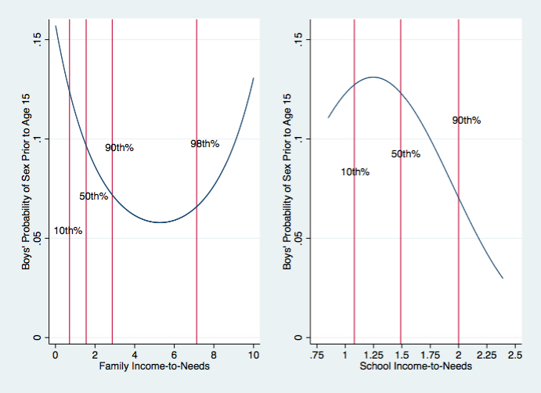
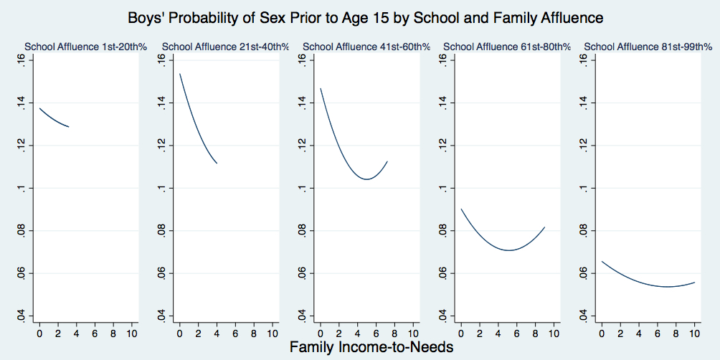

Figure 2a. Nonlinear association between school income-to-needs and early sexual debut for girls. Vertical lines indicate percentiles for the income-to-needs distributions. Figure 2b. Predicted probabilities of sex prior to age 15 for girls as a function of family and school income-to-needs.
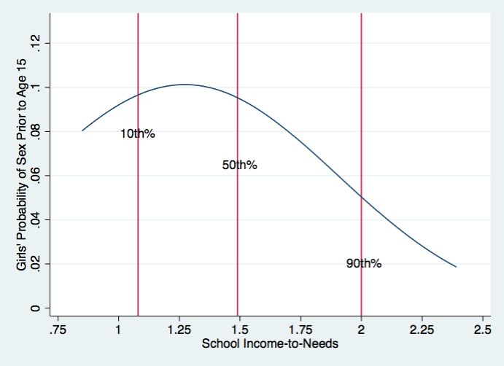
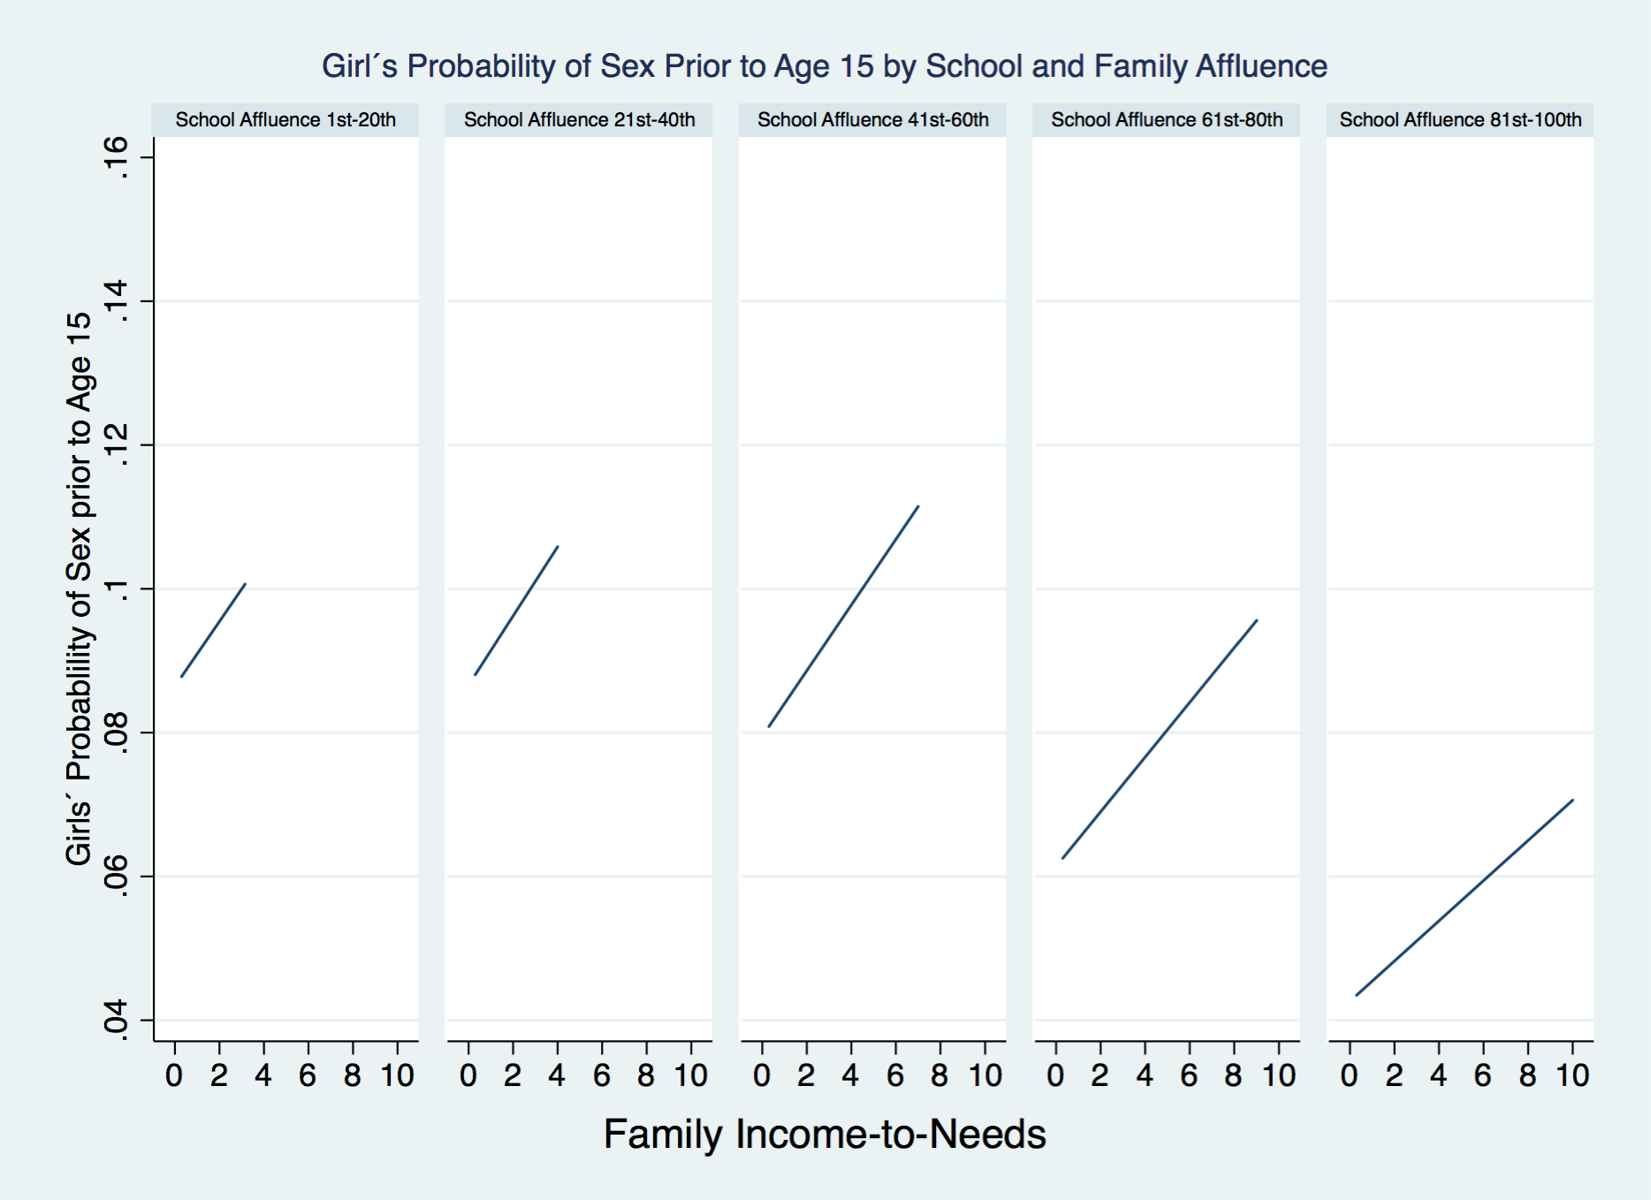

Figure 3. Nonlinear associations between family income-to-needs and conduct problems for boys and girls.
