Sleep patterns and insomnia in a large population-based
study of middle-aged and older adults:
The Tromsø study 2015-2016

Short title: sleep patterns and insomnia

Børge Sivertsen ^{1,2,3}, Ståle Pallesen ⁴, Oddgeir Friborg ⁵, Kristian Bernhard Nilsen ⁶,
Øystein Kvåle Bakke ⁷, Jonas Bjørnskov Goll ⁷, Laila Arnesdatter Hopstock ⁷

¹ Department of Health Promotion, Norwegian Institute of Public Health, Bergen, Norway
² Department of Research & Innovation, Helse Fonna HF, Haugesund, Norway
³ Department of Mental Health, Norwegian University of Science and Technology, Trondheim, Norway
⁴ Department of Psychosocial Science, Faculty of Psychology, University of Bergen, Bergen, Norway
⁵ Department of Psychology, UiT the Arctic University of Norway, Tromsø, Norway
⁶ Section for Clinical Neurophysiology, Department of Neurology, Oslo University Hospital-Ullevål, Oslo, Norway
⁷ Department of Community Medicine, Faculty of Health Sciences, UiT The Arctic University of Norway, Tromsø, Norway

Corresponding author: Professor Børge Sivertsen, Department of Health Promotion, Norwegian Institute of Public Health, Bergen, Norway, Postboks 973 Sentrum, 5808 Bergen, Norway, E-mail: borge.sivertsen@fhi.no
Words/references: 2644 / 37
Conflict of interests: None of the authors declare that they have any conflicts of interests.
Author contributorship: Authors BS drafted the manuscript and conducted the statistical analyses. Authors LAH was responsible for data collection and design of the study. Authors SP, OF, KBN, ØKB, JBG and LAH gave critical revision of the manuscript for important intellectual content. All authors have approved the manuscript being submitted.
SUMMARY

Epidemiological studies assessing adult sleep duration have yielded inconsistent findings, and there are still large variations in estimation of insomnia prevalence according to the most recent diagnostic criteria. Our objective was to describe sleep patterns in a large population of middle-aged and older adults, by employing accurate measures of both sleep duration and insomnia. Data stem from the Tromsø Study (2015-2016), an ongoing population-based study in Northern Norway comprising citizens aged 40 years and older (n=21,083, attendance=64.7%). Sleep parameters were reported separately for weekdays and weekends, and included bedtime, rise time, sleep latency, and total sleep time. Insomnia was defined according to recent diagnostic criteria (International Classification of Sleep Disorders; ICSD-3). The results show that 20% (95% CI:19.4-20.6) fulfilled the inclusion criteria for insomnia. The prevalence was especially high among women (25%), for whom the prevalence also increased with age. For men, the prevalence was around 15% across all age groups. In all, 42% of the women reported to sleep less than 7 hours (mean sleep duration of 7:07 hours), while the corresponding proportion among males was 52% (mean sleep duration of 6:55 hours). We conclude that the proportion of middle-aged and older adults not getting the recommended amount of sleep is worryingly high, as is also the observed prevalence of insomnia. This warrants attention as a public health problem in this population.

Keywords: epidemiology, insomnia, sleep duration, prevalence, gender differences
INTRODUCTION

Sleep problems have in recent years been highlighted as a major public health concern (Chattu et al., 2018). The high and increasing prevalence of sleep problems (Garland et al., 2018, Sivertsen et al., 2019), combined with being associated with both impaired mental (Baglioni et al., 2011) and physical health (Sivertsen et al., 2014), as well as substantial economic costs (Hafner et al., 2017), underscore the importance of obtaining sleep of sufficient duration and quality.
While our sleep need may depend on both genetic and physiological factors, the latest recommendations from the National Sleep Foundations (Hirshkowitz et al., 2015) suggest that a sleep duration of 7-9 and 7-8 hours (± 1 hour to take individual differences into account) is appropriate for adults (18-64 years) and older adults (≥ 65 years), respectively. However, studies have shown that a substantial proportion of adults fail to obtain the recommended amount of sleep. In a large US telephone survey conducted by the Centers for Disease Control and Prevention (CDC) almost two thirds obtained the recommended amounts, whereas an estimated 83.6 million U.S. adults (35%) slept less than the recommended 7 hours (Liu et al., 2016). Moreover, the sleep duration of adults has been reported as declining over the last decades (Bixler, 2009, Ferrara and De Gennaro, 2001), a claim that has been somewhat counterbalanced by a recent systematic review showing mixed and inconsistent trends of sleep duration across studies (Bin et al., 2012). A limitation with many population-based studies is the use of relatively crude sleep measures that do not include important sleep parameters, e.g. sleep onset latency (SOL), hence blurring the distinction between sleep duration and time in bed (TIB). As such, some studies may overstate the true sleep duration and obscure the problem of insufficient sleep.
Lack of assessment of subjective insomnia, as opposed to short sleep duration, using well-documented measures is another limitation of this field. Studies examining the prevalence of insomnia remain far less frequent than studies of sleep duration. Mainly due to methodological differences has been operationalized (Karacan et al., 1983), epidemiologic studies of the prevalence of insomnia symptoms have ranged widely, from 2% (Liljenberg et al., 1989) to 48% (Quera-Salva et al., 1991). Studies employing stricter diagnostic insomnia criteria typically yield narrower estimates, ranging from 6% (Ohayon, 2002) to 15% (Pallesen et al., 2014). The Norwegian HUNT3 study (2006-2008) comprising 40,535 adults found an overall insomnia prevalence of 7.9% (Uhlig et al., 2014) based on the insomnia criteria found in the 5th edition of the Diagnostic and Statistical Manual for Mental Disorders (DSM-5(American Psychiatric Association, 2013)). However, some important discrepancies between formal diagnostic criteria and the sleep items included in the HUNT are present, rendering the prevalence estimates encumbered with some uncertainties. Indeed, updated prevalence estimates are called for, as several studies have also indicated that the prevalence of insomnia has increased over the last decades (Kronholm et al., 2016, Caldwell et al., 2017, Pallesen et al., 2014).
Considering the inconsistent findings and mixture of methods used when assessing adult sleep duration, the large variations when estimating the prevalence of insomnia, and the general call for updated data on insomnia prevalences, the current study had the following aims: to describe sleep patterns in a population more precisely by adjusting the sleep duration for SOL, to provide age and gender-specific estimates of insomnia by using a large population-based study comprising middle-aged and older adults, and examine how sleep patterns and insomnia connect.

METHODS

Setting & participants
The Tromsø Study is an ongoing population-based health study in the municipality of Tromsø, Norway, with seven surveys conducted to date (Tromsø 1-7, 1974-2016, attendance 65-79%). Total birth cohorts and representative population samples have been invited and 45,473 women and men have participated in at least one survey. Data collections included clinical examinations, biological sampling, questionnaires and interviews (Jacobsen et al., 2012). In Tromsø 7 (2015-2016) all citizens aged 40 years and above (32 591) living in the municipality were invited, of which 21 083 women and men aged 40-99 years participated (attendance: 64.7%).

Instruments
Sleep measures
Questions about sleep and educational level were included in a general questionnaire completed online, either before the visit or at study site. Table 1 details the sleep items used in the current study. A slightly modified version of the Bergen Insomnia Scale (BIS (Pallesen et al., 2008)) was used to assess symptoms of insomnia. The original BIS included six items that correspond to the diagnostic criteria for insomnia in the DSM-IV (American Psychiatric Association, 1994). Each item is scored using a scale from 0 to 7, referring to the number of days per week the respondents experience a specific symptom. The first four items (prolonged sleep onset, difficulties maintaining sleep, early morning awakening and non-restorative sleep) assess nocturnal symptoms of insomnia (DSM-IV inclusion criterion A for insomnia), whereas the last two items measure daytime sleepiness or tiredness (affecting school, work, or private life) and dissatisfaction with sleep (DSM-IV inclusion criterion B for insomnia). BIS has demonstrated good psychometric properties (Pallesen et al., 2008). The time frame in the original BIS was last month, which corresponded to the criterion found in the DSM-IV. According to the 5th revision of the DSM (American Psychiatric Association, 2013) and the 3rd and latest version of the International Classification of Sleep Disorders (ICSD-3) (American Academy of Sleep Medicine, 2014), the minimum symptom duration for chronic insomnia was raised to at least three months. Therefore, we added a question asking the participants how long their sleep problems had lasted. Another diagnostic change concerns non-restorative sleep, which has been discarded as an insomnia criterion both in the DSM-5 (American Psychiatric Association, 2013) and the ICSD-3 (American Academy of Sleep Medicine, 2014). Accordingly, the BIS item reflecting this symptom was disregarded in the current insomnia operationalization. As such, in the current study, ICSD-3 insomnia disorder was defined as being present if the participants reported: 1) at least one of the three nocturnal symptoms at least 3 nights per week, and 2) one or both of the two daytime (daytime sleepiness/tiredness and dissatisfaction with sleep) symptoms at least 3 days per week, and 3) reporting a duration of the sleep problems of 3 months or longer. Of note, while these sleep items provide an indication of who may meet the inclusion criteria for an insomnia disorder, we did not assess factors or conditions that may take precedence over the insomnia (such as substance use, another sleep disorder, and coexisting mental disorders and medical conditions).
Self-reported bed- and rise time were provided by the respondents in hours and minutes and were reported separately for weekend and weekdays. Time in bed (TIB) was calculated by subtracting bedtime from rise time. SOL was reported in minutes. Based on the data, a five-point categorical variable was created: 1) “less than 15 minutes”, “15-29 minutes”, “30-59 minutes”, “60-119 minutes”, and “120 or more minutes” for inclusion in specific analyses. Sleep duration was defined as TIB minus SOL. In addition to being used as a continuous variable, sleep duration was also used categorically (< 4:00 hrs, 4:00-4:59 hrs, 5:00-5:59 hrs, 6:00-6:59 hrs, 7:00-7:59 hrs, 8:00-8:59 hrs, 9:00-9:59 hrs, 10:00-10:59 hrs, and ≥11:00 hrs). Finally, sleep efficiency (SE) was calculated, defined as the ratio of sleep duration to TIB (multiplied by 100 to yield percentages).

------------------------------
Please insert Table 1 about here
------------------------------

Statistics
IBM SPSS version 26 (SPSS Inc., Chicago, IL USA) for Windows was used for all analyses. Independent samples t-tests and chi-square tests were used to examine differences in sleep variables across sex and age (5-year age groups), respectively. We controlled for multiple comparisons using the standard false discovery rate (FDR) method with a false-positive rate of 5% (q = 0.05), as outlined by Benjamini and Hochberg (1995). Missing values were handled using listwise deletion.

Ethics
Tromsø 7 was approved by the Regional Committee for Medical and Health Research Ethics North (REC North 2014/940). Written informed consent was obtained after the participants had received detailed information about the study.

RESULTS

Descriptive characteristics
In all 21,083 participants were included in the study (51.9% women and 48.1% men, mean age of 57.3 (SD=11.5). A majority of the participants had completed high school degree (77.2%).

Sleep patterns
Table 2 shows the detailed patterns of self-reported bedtime, rise time, TIB, sleep duration, SOL, and sleep efficiency for the total sample, and in addition stratified by sex. The mean bedtime on weekdays was 23:18, significantly later for men (23:23) than women (23:13). Mean TIB for weekdays was 7:22 hours (men: 7:13 hours and women: 7:30 hours), whereas mean sleep duration was 7:01 hours (men: 6:55 hours and women: 7:07 hours; all Ps< .001). Among women, 42.2% slept less than 7 hours, while the corresponding proportion among males was 51.8%. Among the short sleepers (< 7 hours), the mean sleep duration was 6:13 hours (men 6:14 hours; women 6:12 hours, while the median sleep duration was 6:25 hours (men 6:25 hours; women 6:29 hours).

---------------------------------------------

Please insert Table 2
---------------------------------------------
Mean SOL on weekdays was 19 min, with 44.3% reporting SOL less than 15 min, and 28.3% reporting SOL longer than 30 min (see Figure 1 for details). SOL was significantly longer for women than men (P < 0.001). There were no significant differences in SOL between weekdays and weekends.
Bedtime during weekends (00:04) was, on average, 46 min later than on weekdays, while the corresponding rise time difference between weekends and weekdays was 1 h and 25 min. Also, taking SOL into consideration, this reflected that the participants slept on average 41 minutes longer during weekends than weekdays. Both rise- and bedtime discrepancies between weekdays and weekends were similar for men and women. The distribution of sleep duration on weekdays and at weekends in males and females is presented in Figure 2.

---------------------------------------------

Please insert Figures 1 and 2 about here
---------------------------------------------
As displayed in Figure 3, the weekday-weekend difference in sleep duration were largest among the middle-age/working-age participants (< 65 years), and were gradually reduced with increasing age. In the oldest age group, there were no significant differences in sleep duration between weekdays and weekends.
---------------------------------------------

Please insert Figure 3 about here
---------------------------------------------

Insomnia
The overall prevalence of insomnia according to the ICSD-3 criteria was 20% (95% CI:19.4%-20.6%), significantly higher among women (24.8% [95% CI: 23.9%-25.6%]) compared to men (14.9% [95% CI: 14.2%-15.6%]). As displayed in Figure 4, age was significantly and positively associated with the prevalence of insomnia among women, but not in men (age × sex interaction: P = < .001).
---------------------------------------------

Please insert Figure 4 about here
---------------------------------------------

Insomnia and sleep duration
Participants with insomnia had an average weekday sleep duration of 6 h and 26 min, which was significantly shorter than those without insomnia (7 h and 07 min; P < 0.001). Also, a significantly larger proportion of participants with insomnia slept fewer than 6 h compared to those without insomnia (21.9% versus 9.2%, respectively; P < 0.001; Figure 5).

---------------------------------------------

Please insert Figure 5 about here
---------------------------------------------

DISCUSSION

This large population-based study from 2015-2016 shows that one in five adults fulfill the inclusion criteria for an insomnia disorder according to the ICSD-3. The prevalence was significantly higher among women (25%), which also increased with age. For men, the prevalence was around 15% irrespective of age groups. With regard to obtaining the recommended amount of sleep, 42% of the women reported sleeping less than 7 hours (mean of 7:07 hours), while the corresponding proportion among males was 52% (mean sleep duration of 6:55 hours).
The observed sleep duration in the current study was comparable to that of a 20-year-old study from Norway, the Hordaland Health Study, which used similarly detailed items to assess sleep behavior. In that study, Ursin et al. (2005) found that middle-aged women reported a weekday sleep duration of 7:11 hours, while men slept 6:52 hours, which is only a 3-4-minute difference from the current study. Also, the findings for weekend sleep duration were comparable between those two studies. As such, the current study provides new and updated data which corroborate the systematic review by Bin et al. (2012), who concluded that self-reported sleep duration of adults has not changed notable since the 1960s. The sex difference reported in terms of sleep duration has previously been supported in a meta-analysis based on objective sleep measures, such as polysomnography and actigraphy (Ohayon et al., 2004), and may be caused by several biological mechanisms (Mong and Cusmano, 2016). The fact that weekday and weekend sleep duration converge with advancing age, may reflect reduced formal (e.g. work) obligations with age as well as a advancement of the circadian rhythm with age (Carrier et al., 2002).
Interestingly, the current study also found relatively large differences between weekend- and weekday sleep estimates, which likely reflect social jetlag. While beyond the scope of the current study, several studies have linked social jetlag to several potential health risks (Beauvalet, Quiles et al., 2017), and future studies should explore to what extent social jetlag may be associated with other domains of daytime functioning.
Regarding sleep loss, we do find it troublesome that 4 in 10 women and 5 in 10 men reported to receive less than the recommend 7 hours of nocturnal sleep. Given the many demonstrated health and societal corollaries of chronic sleep deficits (Chattu et al., 2018), encouraging individuals to obtain sufficient duration and quality of sleep becomes an important public health message.
The high rate of insomnia observed in the current study is noteworthy; and far higher than previous prevalence estimates adhering to common diagnostic criteria (Ohayon, 2002, Pallesen et al., 2014, Uhlig et al., 2014). Whether this discrepancy reflects an actual increase of insomnia prevalence over the last few years is unclear, which is a fair speculation as the city of Tromsø in Norway, which is located over 300 km north of the Arctic Circle, at 69° Northern latitude, may be less representative of regions further south with less extreme variations of daylight throughout the year. Studies of the general population in Tromsø do indeed show some delay in sleep phase, with increased insomnia problems and fatigue during the winter as compared to the summer season (Friborg et al., 2014, Husby and Lingjaerde, 1990, Johnsen et al., 2012, Johnsen et al., 2013). However, the seasonal flow in insomnia seems to be in the weak-to-moderate range, whereas seasonal changes in fatigue is generally more pronounced (Friborg et al., 2014, Friborg et al., 2018). It is therefore conceivable that these seasonal upswings may contribute to the divergence between results across studies. Findings from another large population-based study in Norway (the HUNT3 study) that collected data over a period of 2 years, found however no evidence of monthly variations neither in insomnia rate nor TIB (Sivertsen et al., 2011), even though the amount of daylight varied from 4 to 21 hours across the year. That study took however place at a more southern latitude.
It should also be noted that the majority of participants in the current study had a high school degree, which one should have in mind when comparing the insomnia prevalence to other studies. In fact, symptoms of insomnia have been found to be twice as common amongst people with low education (about 20 per cent) compared with those with a higher education {Sivertsen, 2009 #265}.

Methodological considerations
The strengths of the present study include the combination of a large sample size, the high attendance (64.7%), the representativeness of the sample, and the broad range of detailed sleep parameters assessed. The latter comprises both a close approximation of the inclusion criteria of insomnia disorder according to the ICSD-3 (American Academy of Sleep Medicine, 2014), as well as a more detailed approximation of actual sleep duration (as opposed to merely assessing TIB). However as mentioned, while the current study does provide an indication of who may meet the inclusion criteria for an insomnia disorder, we did not assess factors or conditions that may take precedence over the insomnia, which taken together most likely would have yielded lower insomnia prevalence estimates. Some other study limitations should also be noted. First, all data used in the current study were based on self-report. As such, no clinician-verified information or objective sleep measures, such as polysomnography, were available to corroborate the observed estimates. Especially for the sleep duration approximation, it would have been useful to compare the self-report data with e.g. accelerometer data. However, it has been argued that self-reported quantitative estimates of habitual sleep behavior is reliable (Gehrman et al., 2002). Second, we did not have data on other sleep disorders, which could have provided information about potential overlap between sleep disorders. Similarly, we did not included data on sleep medication use, which is important issue as sleep duration may be influenced by sleep medications {Dundar, 2004 #62}. Hence, estimates of sleep duration should ideally have been adjusted for sleep medication use. Third, we did not have the opportunity to perform a non-response study, which could have improved the generalizability of the estimates further. Fourth, the participants in the present study were all above 40 years of age, which limits the generalizability to those being older. Finally, although the BIS does include tiredness/sleepiness as a proxy for daytime impairment, we would ideally have included a more detailed measure of functional impairments caused by the insomnia, in line with the ICSD-3 (American Academy of Sleep Medicine, 2014). The fact that WASO and early morning awakenings were not assessed and consequently not subtracted from TIB when calculating TST may have overestimated TST. On the other hand it should be noted that daytime napping was not included in the estimate of TST.

.

Table 1. Sleep questionnaire used in the Tromsø Study 2015-2016.
The Bergen Insomnia Scale
How many days a week… (0-7 days)
- … does it take you more than 30 minutes to fall asleep after the light are switched off?
- …. are you awake for more than 30 minutes between periods of sleep?
- … do you wake up more than 30 minutes earlier than you wished without managing to fall asleep again?
- … do you feel that you have not had enough rest after waking up?
- …are you so sleepy/tired that it has affected you at work or in your private life?
- …are dissatisfied with your sleep?

If you have sleep problem, how long have they lasted?
(< 1 week, 1-3 weeks, 1 month, 2 months, 3 months, 4-6 months, 7-12 months, 1-5 years, 6-10 years, More than 10 years)

Sleep behavior
When do you usually go to sleep at night?
…on work days/weekdays? …on weekends/holidays?
(hours and minutes)

How long do you lie awake before falling asleep?
…on work days/weekdays? …on weekends/holidays?
(minutes)
When do you usually wake up in the morning?
…on work days/weekdays? …on weekends/holidays?
(hours and minutes)

Table 2. Sleep characteristics. The Tromsø Study 2015-2016.
 | Females |  | Males |  | Statistics | All
 | Mean/% | SD/n | Mean/% | SD/n | p-value* | Mean/% | SD/n
Week days
Bedtime | 23:13 | 0:49 | 23:23 | 0:56 | < .001 | 23:18 | 0:53
Rise time | 6:43 | 1:07 | 6:35 | 1:06 | < .001 | 6:39 | 1:06
Time in bed | 7:30 | 1:04 | 7:13 | 1:03 | < .001 | 7:22 | 1:04
Sleep duration | 7:07 | 1:05 | 6:55 | 1:04 | < .001 | 7:01 | 1:05
Short sleep duration (<7 h) | 42.2% | 3923 | 51.8% | 4580 | < .001 | 46.9% | 8503
Sleep onset latency | 0:22 | 0:24 | 0:17 | 0:16 | < .001 | 0:19 | 0:20
Sleep efficiency (%) | 95.0 | 5.6 | 95.9 | 4.4 | < .001 | 95.4 | 5.1
Weekends
Bedtime | 00:00 | 0:56 | 00:09 | 1:01 | < .001 | 00:04 | 0:58
Rise time | 8:08 | 1:20 | 8:00 | 1:23 | < .001 | 8:04 | 1:22
Time in bed | 8:08 | 1:13 | 7:51 | 1:13 | < .001 | 8:00 | 1:13
Sleep duration | 7:48 | 1:16 | 7:35 | 1:14 | < .001 | 7:42 | 1:15
Short sleep duration (<7 h) | 20.4% | 1894 | 27.2% | 2433 | < .001 | 23.6% | 4327
Sleep onset latency | 0:20 | 0:22 | 0:16 | 0:15 | < .001 | 0:18 | 0:20
Sleep efficiency (%) | 95.7 | 5.3 | 96.4 | 4.0 | < .001 | 96.0 | 4.7
* P-values are corrected for multiple comparisons, based on False Discovery Rate (FDR), as outlined by Benjamini and Hochberg (1995).

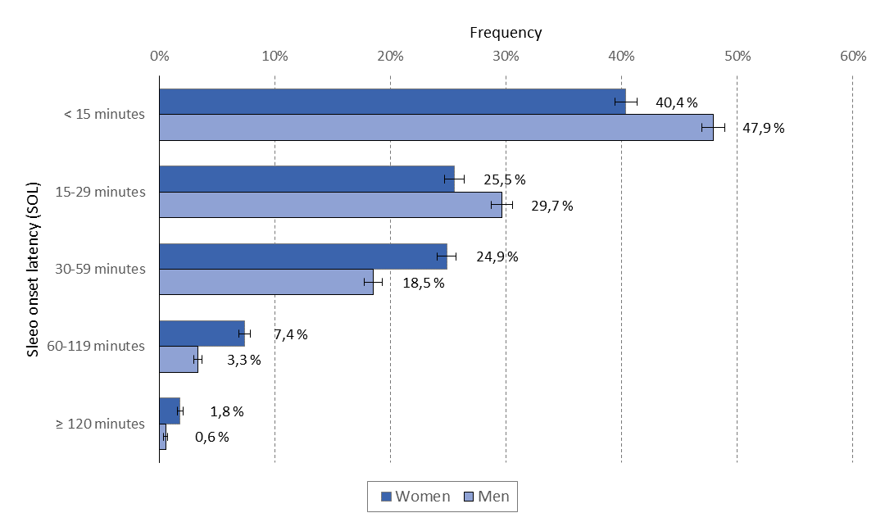

Figure 1. Sleep onset latency on work days/weekday by sex. Error bars represent 95% confidence intervals. The Tromsø Study 2015-2016.

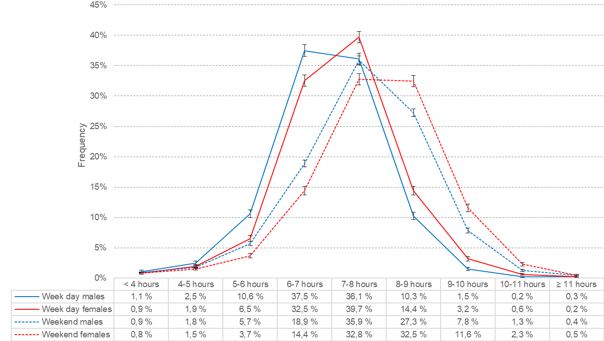

Figure 2. Sleep duration on work days/weekdays (solid lines) and weekends/holidays (dashed lines) by sex. Error bars represent 95% confidence intervals. The Tromsø Study 2015-2016.

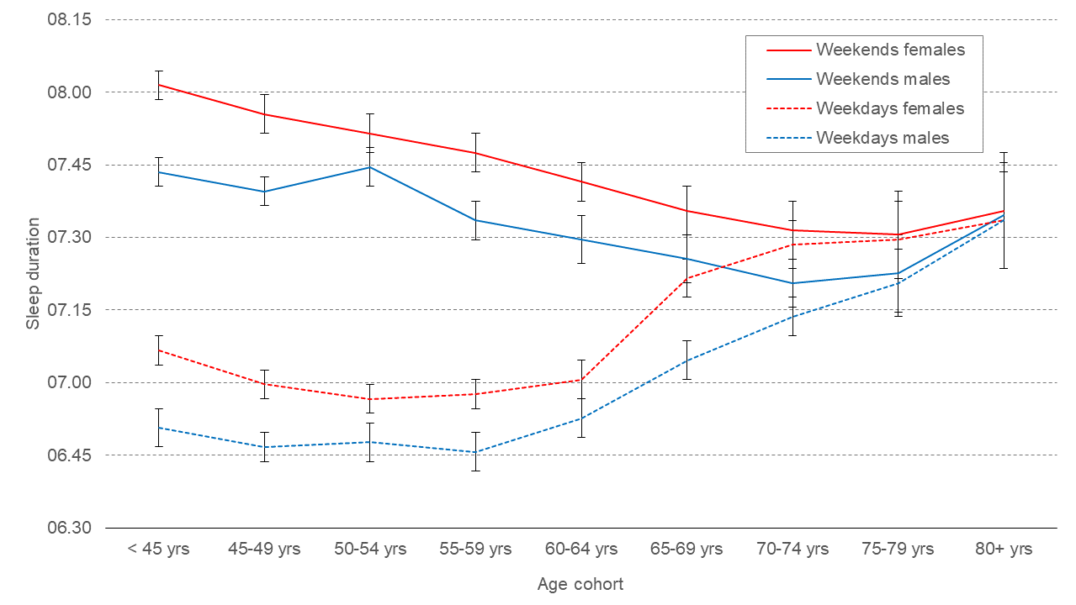

Figure 3. Sleep duration on work days/weekdays (dashed lines) and weekends/holidays (solid lines) by age and sex. Error bars represent 95% confidence intervals. The Tromsø Study 2015-2016.

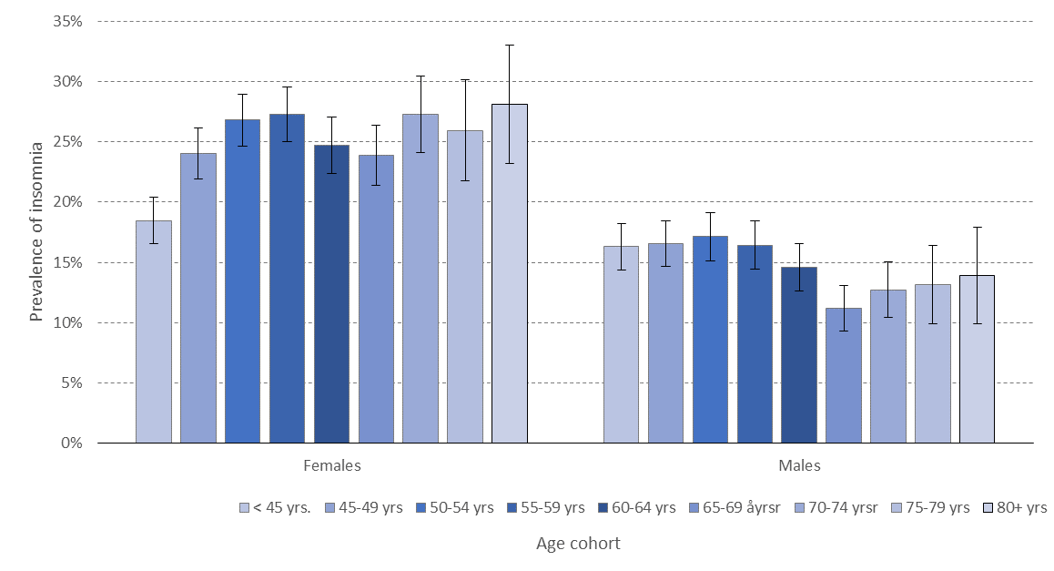
Figure 4. Prevalence of ICSD-3 insomnia by sex and age cohort. Error bars represent 95% confidence intervals. The Tromsø Study 2015-2016.
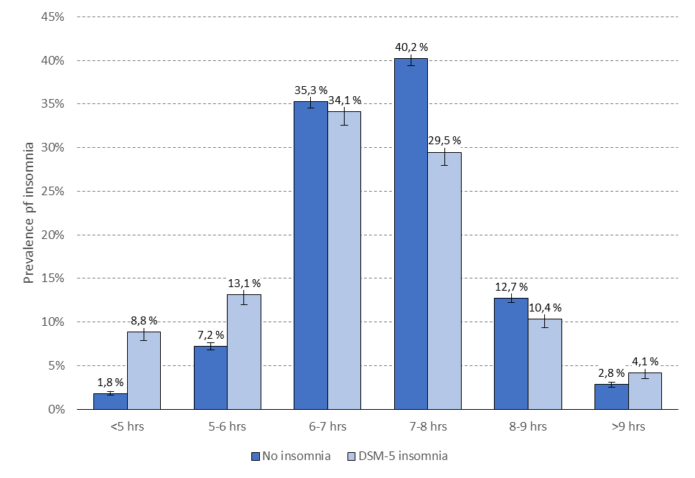
Figure 5. Sleep duration categories (weekday) stratified by insomnia. Error bars represent 95% confidence intervals. The Tromsø Study 2015-2016.

REFERENCES

American Academy of Sleep Medicine International Classification of Sleep Disorders. Coding (3rd ed.). American Academy of Sleep Medicine, Darien, IL, 2014.
American Psychiatric Association Diagnostic and Statistical Manual of Mental Disorders (4 ed.). American Psychiatric Publishing, Washington, DC, 1994.
American Psychiatric Association Diagnostic and Statistical Manual of Mental Disorders (5 ed.). American Psychiatric Publishing, Washington, DC, 2013.
Baglioni, C., Battagliese, G., Feige, B., et al. Insomnia as a predictor of depression: a meta-analytic evaluation of longitudinal epidemiological studies. J Affect Disord, 2011, 135: 10-19.
Benjamini, Y. and Hochberg, Y. Controlling the False Discovery Rate - a Practical and Powerful Approach to Multiple Testing. Journal of the Royal Statistical Society Series B-Methodological, 1995, 57: 289-300.
Bin, Y. S., Marshall, N. S. and Glozier, N. Secular trends in adult sleep duration: a systematic review. Sleep Med Rev, 2012, 16: 223-230.
Bixler, E. Sleep and society: an epidemiological perspective. Sleep Med, 2009, 10 Suppl 1: S3-6.
Caldwell, J., Knapik, J. and Lieberman, H. Trends and factors associated with insomnia and sleep apnea in all United States military service members from 2005 to 2014. J Sleep Res, 2017, 26: 665-670.
Carrier, J., Paquet, J., Morettini, J. and Touchette, E. Phase advance of sleep and temperature circadian rhythms in the middle years of life in humans. Neurosci Lett, 2002, 320: 1-4.
Chattu, V. K., Manzar, M. D., Kumary, S., Burman, D., Spence, D. W. and Pandi-Perumal, S. R. The Global Problem of Insufficient Sleep and Its Serious Public Health Implications. Healthcare (Basel), 2018, 7
Ferrara, M. and De Gennaro, L. How much sleep do we need? Sleep Med Rev, 2001, 5: 155-179.
Friborg, O., Rosenvinge, J. H., Wynn, R. and Gradisar, M. Sleep timing, chronotype, mood, and behavior at an Arctic latitude (69 degrees N). Sleep Med, 2014, 15: 798-807.
Friborg, O., Sundby, J., Rognmo, K., et al. No seasonality in cognitive performance among adolescents at a subarctic latitude (69degreeN). Applied Cognitive Psychology, 2018, 32: 217-224.
Garland, S. N., Rowe, H., Repa, L. M., Fowler, K., Zhou, E. S. and Grandner, M. A. A decade's difference: 10-year change in insomnia symptom prevalence in Canada depends on sociodemographics and health status. Sleep Health, 2018, 4: 160-165.
Gehrman, P., Matt, G. E., Turingan, M., Dinh, Q. and Ancoli-Israel, S. Towards an understanding of self-reports of sleep. J Sleep Res, 2002, 11: 229-236.
Hafner, M., Stepanek, M., Taylor, J., Troxel, W. M. and Van Stolk, C. Why Sleep Matters-The Economic Costs of Insufficient Sleep: A Cross-Country Comparative Analysis. Rand Health Q, 2017, 6: 11.
Hirshkowitz, M., Whiton, K., Albert, S. M., et al. National Sleep Foundation's sleep time duration recommendations: methodology and results summary. Sleep Health, 2015, 1: 40-43.
Husby, R. and Lingjaerde, O. Prevalence of reported sleeplessness in northern Norway in relation to sex, age and season. Acta Psychiatr Scand, 1990, 81: 542-547.
Jacobsen, B. K., Eggen, A. E., Mathiesen, E. B., Wilsgaard, T. and Njolstad, I. Cohort profile: the Tromso Study. Int J Epidemiol, 2012, 41: 961-967.
Johnsen, M. T., Wynn, R., Allebrandt, K. and Bratlid, T. Lack of major seasonal variations in self reported sleep-wake rhythms and chronotypes among middle aged and older people at 69 degrees North: the Tromso Study. Sleep Med, 2013, 14: 140-148.
Johnsen, M. T., Wynn, R. and Bratlid, T. Is there a negative impact of winter on mental distress and sleeping problems in the subarctic: the Tromso Study. BMC Psychiatry, 2012, 12: 225.
Karacan, I., Thornby, J. and Williams, R. Sleep disturbance: a community survey. In: C. GUILLEMINAULT and E. LUGARESI (Eds), Sleep/wake disorders: natural history, epidemiology, and long-term evolution. Raven Press, New York, NY 1983: 37-60.
Kronholm, E., Partonen, T., Harma, M., et al. Prevalence of insomnia-related symptoms continues to increase in the Finnish working-age population. J Sleep Res, 2016, 25: 454-457.
Liljenberg, B., Almqvist, M., Hetta, J., Roos, B. and Ågren, H. Age and the prevalence of insomnia in adulthood. Eur J Psychiatry, 1989, 3: 5-12.
Liu, Y., Wheaton, A. G., Chapman, D. P., Cunningham, T. J., Lu, H. and Croft, J. B. Prevalence of Healthy Sleep Duration among Adults--United States, 2014. MMWR Morb Mortal Wkly Rep, 2016, 65: 137-141.
Mong, J. A. and Cusmano, D. M. Sex differences in sleep: impact of biological sex and sex steroids. Philos Trans R Soc Lond B Biol Sci, 2016, 371: 20150110.
Ohayon, M. M. Epidemiology of insomnia: what we know and what we still need to learn. Sleep Med Rev, 2002, 6: 97-111.
Ohayon, M. M., Carskadon, M. A., Guilleminault, C. and Vitiello, M. V. Meta-analysis of quantitative sleep parameters from childhood to old age in healthy individuals: developing normative sleep values across the human lifespan. Sleep, 2004, 27: 1255-1273.
Pallesen, S., Bjorvatn, B., Nordhus, I. H., Sivertsen, B., Hjornevik, M. and Morin, C. M. A new scale for measuring insomnia: the Bergen Insomnia Scale. Percept Mot Skills, 2008, 107: 691-706.
Pallesen, S., Sivertsen, B., Nordhus, I. H. and Bjorvatn, B. A 10-year trend of insomnia prevalence in the adult Norwegian population. Sleep Med, 2014, 15: 173-179.
Quera-Salva, M. A., Orluc, A., Goldenberg, F. and Guilleminault, C. Insomnia and use of hypnotics: study of a French population. Sleep, 1991, 14: 386-391.
Sivertsen, B., Lallukka, T., Salo, P., et al. Insomnia as a risk factor for ill health: Results from the large population-based prospective HUNT study in Norway. Journal of Sleep Research, 2014, 23: 124-132.
Sivertsen, B., Overland, S., Krokstad, S. and Mykletun, A. Seasonal variations in sleep problems at latitude 63 degrees -65 degrees in Norway: The Nord-Trondelag Health Study, 1995-1997. Am J Epidemiol, 2011, 174: 147-153.
Sivertsen, B., Vedaa, O., Harvey, A. G., et al. Sleep patterns and insomnia in young adults: A national survey of Norwegian university students. J Sleep Res, 2019, 28: e12790.
Uhlig, B. L., Sand, T., Odegard, S. S. and Hagen, K. Prevalence and associated factors of DSM-V insomnia in Norway: the Nord-Trondelag Health Study (HUNT 3). Sleep Med, 2014, 15: 708-713.
Ursin, R., Bjorvatn, B. and Holsten, F. Sleep duration, subjective sleep need, and sleep habits of 40- to 45-year-olds in the Hordaland Health Study. Sleep, 2005, 28: 1260-1269.

