Addressing the fragmentation of global health: the Lancet Commission on synergies between universal health coverage, health security, and health promotion

Gorik Ooms, Trygve Ottersen, Albrecht Jahn, Irene Akua Agyepong
Department of Global Health and Development, London School of Hygiene & Tropical Medicine, London WC1H 9SH, UK (GO); Division for Health Services, Norwegian Institute of Public Health, Oslo, Norway (TO); Department of Community Medicine and Global Health and Centre for Global Health, University of Oslo, Oslo, Norway (TO); Heidelberg Institute of Global Health, University of Heidelberg, Heidelberg, Germany (AJ); Dodowa Health Research Center, Research and Development Division, Ghana Health Service, Dodowa, Ghana (IAA); and Public Health Faculty, Ghana College of Physicians and Surgeons, Accra, Ghana (IAA)
gorik.ooms@lshtm.ac.uk

Global health is fragmented. Many stakeholders pursue their own agenda while neglecting other important goals for global health. Some global health actors, for example, focus on strengthening health security without attention to universal health coverage (UHC), primary health care (PHC), and population-based health promotion. Prevention is a key part of PHC and UHC, but efforts to ensure PHC or make progress towards UHC often do not include population-based prevention efforts. Proponents often use broad definitions of their agenda in declarations and statements, while applying much narrower definitions in practice. If these tensions are not addressed, fragmentation will continue to make local, national, and global efforts inefficient and opportunities will be lost in terms of lives saved and quality of life.

The Sustainable Development Goals (SDGs) and WHO’s general programme of work 2019–2023 (GPW) come with unprecedented potential for coherence. The broad SDGs highlight how the goals and targets are intertwined. With respect to health, this interconnectedness is featured throughout SDG 3 and in other SDG goals. Similarly, WHO’s GPW shows that the organisation’s efforts can be subsumed under three strategic priorities: UHC (1 billion more people benefiting from UHC), health emergencies (1 billion more people better protected from health emergencies), and healthier populations (1 billion more people enjoying better health and wellbeing). WHO’s GPW underscores the importance of pursuing these priorities in an integrated way (figure).

Figure: A set of interconnected strategic priorities and goals to ensure healthy lives and promote wellbeing for all at all ages from WHO’s general programme of work 2019–2023. Reprinted from WHO’s Thirteenth general programme of work, 2019–2023.

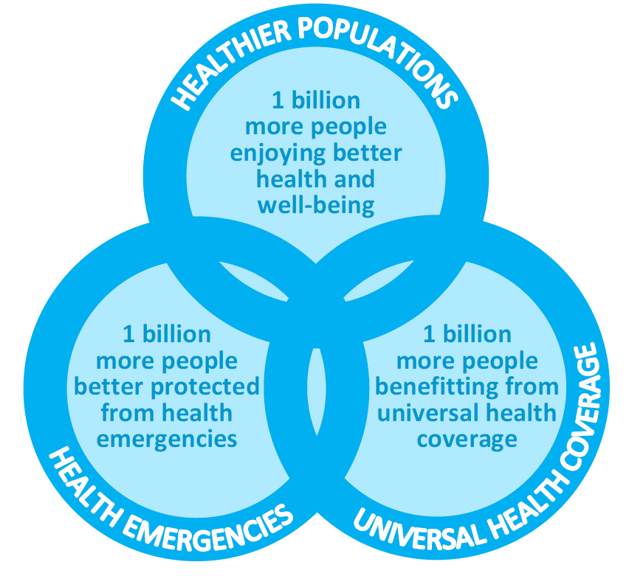
However, some drivers of fragmentation between these three priorities and corresponding agendas are powerful. Path dependency is one. Some global health institutions, initiatives, and programmes have narrow mandates that are difficult to change—a challenge much debated in the context of vertical health programmes. Another driver of fragmentation is diverging national interests, especially when countries claim that their own interests come first. This driver of fragmentation may intensify, and, as Macfarlane and colleagues suggest, steer global health cooperation towards efforts addressing “common vulnerabilities to the spread of communicable diseases and to the spread of risk factors for non-communicable diseases that necessitates national and international strategies”, and away from efforts tackling “huge inequalities in disease burden between rich and poor countries and between rich and poor people anywhere”. Although the SDGs and WHO’s GPW come with great potential for integration, they could also give rise to further fragmentation. Given the ambition of the wide-ranging SDGs, which are much broader than the preceding Millennium Development Goals, some actors might justify prioritising UHC with reference to SDG 3.8, whereas others might prioritise health security with reference to SDG 3.d. The Lancet Commission on synergies between UHC, health security, and health promotion aims to overcome fragmentation and realise the potential for coherence in global health. The Commission will systematically examine intersections between these leading agendas in global health. Inspired by WHO’s Maximizing Positive Synergies initiative, the Commission will find synergies between the three agendas. The Commission will identify a set of key policies, institutional capacities, decision-support systems, and interventions that each contributes across the three agendas and makes progress in one area amplify progress in the others. The findings will help the many and diverse stakeholders in global health better align their efforts, cooperate more efficiently, and save and improve more lives.

The synergies Commission will be co-chaired by Irene Akua Agyepong and Gorik Ooms and hosted by the London School of Hygiene & Tropical Medicine, the Norwegian Institute of Public Health, and the Heidelberg Institute of Global Health. It will bring together 24 scholars from 20 countries who have expertise cutting across the three agendas (appendix). Additionally, 19 policy makers, or scholars working closely with policy makers, will comprise an advisory board. The synergies Commission has its first meeting in London, UK, on Sept 10–12, 2018, and aims to publish its final report in 2020.

The Commission’s report will offer actionable recommendations for multiple actors in global health. These recommendations should help ensure that investments in UHC, health security, and health promotion realise their full potential for global health.

We declare no competing interests.
The Lancet Commission on synergies between universal health coverage, health security, and health promotion is supported by the German Federal Ministry for Economic Cooperation and Development (implemented by the Gesellschaft für Internationale Zusammenarbeit), the Norwegian Agency for Development Cooperation, the Swiss Agency for Development and Cooperation, and the Wellcome Trust. The funders were not involved in writing this Comment.

WHO. Thirteenth general programme of work, 2019–2023. Geneva: World Health Organization, 2018. http://apps.who.int/gb/ebwha/pdf_files/WHA71/A71_4-en.pdf (accessed Aug 31, 2018).
Mills A. Mass campaigns versus general health services: what have we learnt in 40 years about vertical versus horizontal approaches? Bull World Health Organ 2005; 83: 315–16.
Macfarlane SB, Jacobs M, Kaaya EE. In the name of global health: trends in academic institutions. J Public Health Policy 2008; 29: 383–401.
World Health Organization Maximizing Positive Synergies Collaborative Group. An assessment of interactions between global health initiatives and country health systems. Lancet 2009; 373: 2137–69.

