Figure 2. Best fitting EFA models.
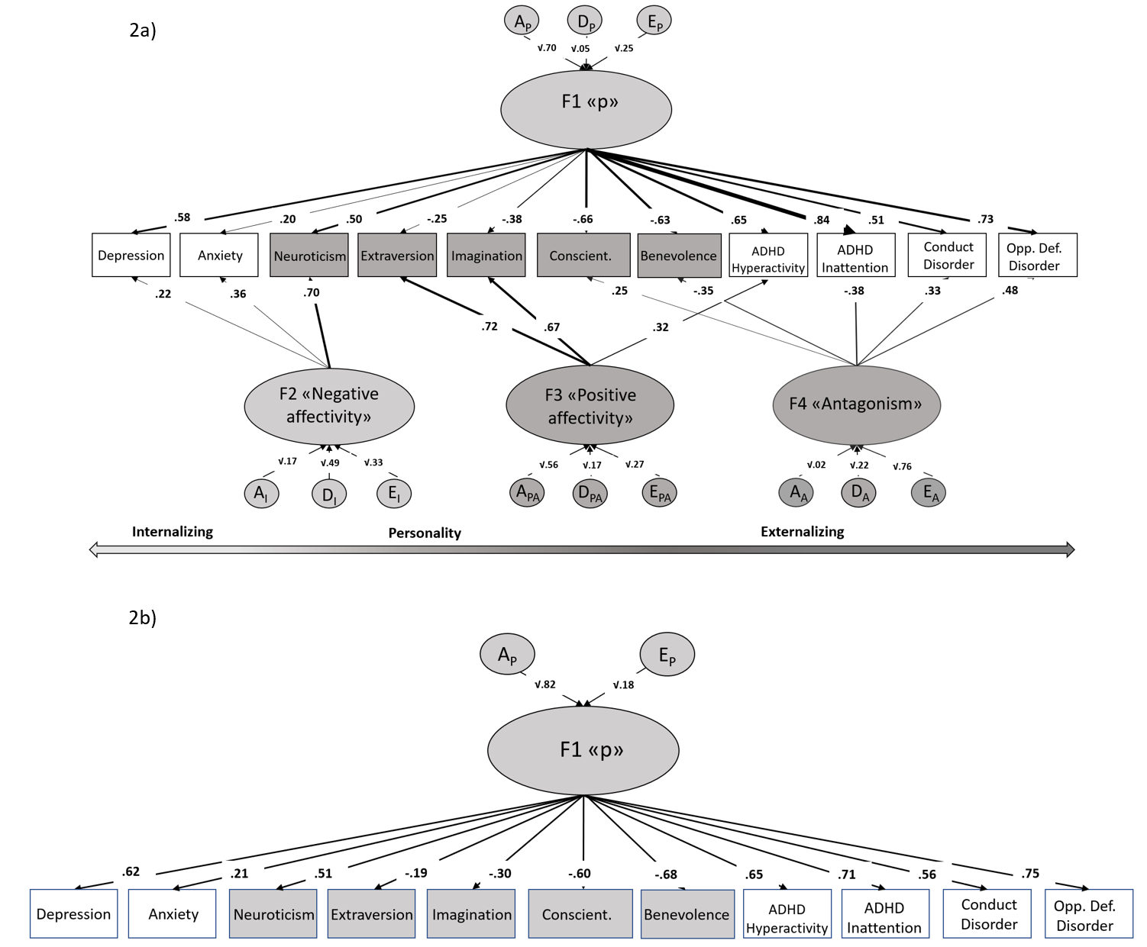
Note: Loadings below .20 are not shown in figure 2a. A = Broad-sense genetic influences (including both additive and non-additive/dominance effects); E = unique environmental influences and measurement error.

